CHILD’S DETAILS

First Name: ____________________________ Surname: ________________________
(as per birth certificate) (as per birth certificate)

Name by which child is known: ____________________ Boy Girl

Date of Birth: ___________________________PPS No.: _________________________

Address at which the child resides (proof of Address required utility bill-ESB/Telephone No.)
________________________________________________________________________

Child’s place in family :__________________________ Nationality ________________
(if not born in Ireland, date on which child arrived in Ireland: ________________________________________________________________________

Name of Siblings already at school: _________________________________________
________________________________________________________________________

Religion________________________ Date of Baptism:(if relevant):_________________
Place of Baptism: (if relevant): ______________________________________________

Name & Address of Pre School attended: ___________________________________
_______________________________________________________________________
1st year completed Yes No
2nd year completed Yes No

Permission to liaise with Pre School Yes No

Is one of the pupil’s mother tongues (i.e. language spoken at home) Irish or English
Yes: No:

Language spoken at home: ____________________________________________

English Language Ability (if relevant): Please tick one of the following
Poor Basic understanding: Competent Language Skills
Do you need help with English Translation? Yes ; No

Who do we contact to help Parents with English translation (if relevant)
Name: _________________________________ Contact details: _____________
Relation: ___________________________________________________________

DECLARATION

I wish to enrol my Son/Daughter as a pupil of Scoil Cholmcille Primary School. If my child is accepted for entry, I hereby undertake for myself and for him/her to observe the rules and regulations of the school.

Parent’s/Guardian’s Signature __________________________________

__________________________________

Date: __________________________________

Principal’s Signature ________________________________________

Date: ______________________________________________________

CONSENT

Do you give Parental Consent in these instances:
Our Code of Behaviour ensures that desirable behaviour is rewarded
and that all pupils are treated fairly and equally. Do you comply with

(1) The School Code of Behaviour Yes ; No
(2) The RSE and Stay Safe Programmes Yes ; No:
(3) Assessment in Literacy and Numeracy Yes ; No:

SCHOOL WEB/SCHOOL LITERATURE AND MEDIA

Please browse the web to see lots of displays, pupils’ work, information and developments that are taking place in Scoil Cholmcille Address: www.scoilcolmcillelk.ie

Should you not wish to consent your child to appear on our school web site, or on our new class blogs, or on our school literature and media, please write a note into the secretary within four weeks of your child’s starting date.

I/We consent ___________________________________________________
(Parent/Guardian)
Date: ________________________________________________________________

SEESAW

Seesaw (http://seesaw.me) is a secure online online journal where students can document and reflect on what they are learning in class.

I give consent for my child, to use Seesaw for class activities.

I/We consent ___________________________________________________________
(Parent(s)/Guardian(s).
Date: ________________________________________________________________

We gather and process your child’s personal data for the purpose of administering the education of your child. To facilitate this, we will input your child’s data into the school’s Management Information System, Aladdin. Aladdin is a secure software as a service application, which is owned and run by Cloudware Ltd. (T/A/ Aladdin Schools), from where the data is only processed for the above purpose.

MOTHER’S DETAILS

First Name: ________________________________ Surname: ____________________

Maiden Name: ____________________________________________________________
Mobile No.: _____________________________Home Tel. No. _____________________
Email Address: ____________________________________________________________
Nationality _____________________________ Language spoken at home: ___________
Present Employment ________________________Work Tel. No.: ___________________

FATHER’S DETAILS

First Name: ______________________________ Surname: ________________________

Mobile No.: ______________________________ Home Tel. No.: ___________________
Email address: ____________________________________________________________
Nationality: _______________________________ Language spoken at home: _________
Present Employment ______________________ Work Tel. No.:_____________________

Mobile Number to be used for TEXT-A-PARENT: _______________________________
(Mother or Father’s mobile number)

Arrangements if child is sick in school:

Please provide the name and telephone numbers for two people that the school may contact in the event of being unable to reach you:
(1) Name of person to collect: ___________________ _______Tel. No. ______________
Relation to parent: ______________________________________________________

(2) Name of person to collect: ___________________________ Tel. No. _____________
Relation to parent: ______________________________________________________

Who is the child’s legal guardian? Mother ; Father: ; Other:
___________________________________________________________

Has your child to contend with any special home difficulties that may require our additional support: Yes ; No:

Details: ___________________________________________________

POD INFORMATION

To which ethnic or cultural background group does your child belong (please tick one)? (Categories are taken from the Census of Population)

White Irish Irish Traveller Roma

Any other White Background Black African Any other black background

Chinese Any other Asian Other (inc. background mixed background
No consent

What is your child’s religion?

Roman Catholic Church of Ireland Presbyterian
(Incl. Protestant)

Methodist, Wesleyan Jewish Muslim (Islamic)

Orthodox Apostolic or Pentecostal Hindu
Greek, Coptic, Russian

Buddhist Jehovah’s Witness Lutheran

Atheist Baptist Agnostic

Other Religions No Religion No consent

I consent for this information to be stored on the Primary Online Database (POD) and transferred to the Department of Education and Skills and any other primary school my child may transfer to during the course of their time in primary school.

Signed __________________________________________________ Parent/Guardian

Date: ___________________________________________________

Developmental Checklist

Normal Abnormal

Birth History Comment________________________________________________________
Developmental Milestones Yes No
Walking (by 18 months) _______________________________________
Talking (by 2 years) _______________________________________
Toilet Trained (by 3 years) ______________________________________
Please tick () as appropriate:
Satisfactory Unsatisfactory Comment
1. Vision ______________________
2. Hearing ______________________
3. Physical Coordination ______________________
4. Speech ______________________
5. Temperament ______________________
6. Sociability ______________________

Has your child been referred to any other agencies, at any time, before starting school e.g. Speech Therapist, Psychologist, Social Worker,
Occupational Therapist, Physiotherapist, Child and Family Services, etc? Yes No
If yes, please state name of the Speech Therapist, Psychologist, Social Worker etc?
________________________________________________________________________
Should the need arise, are you willing to give parental consent to contact any of the above agencies? Yes No

SPECIFIC HEALTH WEAKNESSES/ALLERGIES
Has your child any specific health weakness? If so please answer yes/no and give details of medications etc. which we should know about.

Asthma Yes No
Psoriasis/Eczema Yes No
Diabetes Yes No
Epilepsy Yes No
Any other health weakness Yes: No
It is the responsibility of parent(s)/guardian(s) to notify the school of any food allergies. Does your child have an allergic reaction to medication for food?
Yes ; No:
If yes please give details: ___________________________________________________
Is your child on any medication? If yes, please give details ________________________
________________________________________________________________________
Name of family Doctor _________________________ Practice: _____________________
Contact details___________________________________________________________
The following documents must accompany this form:

Received

Birth Certificate Yes No
Proof of Address Yes No
Baptismal Certificate (where appropriate) Yes No
PPS No. Yes No

FOR OFFICE USE ONLY

Date of Entry to School _________________________________________

Birth Certificate Received Yes No:

Baptismal Certificate Received Yes No:

School Fees paid Yes No:

School Reports Provided Yes No:

Information entered on POD Yes No:

Information entered on Aladdin Yes No:

Your Child Matters

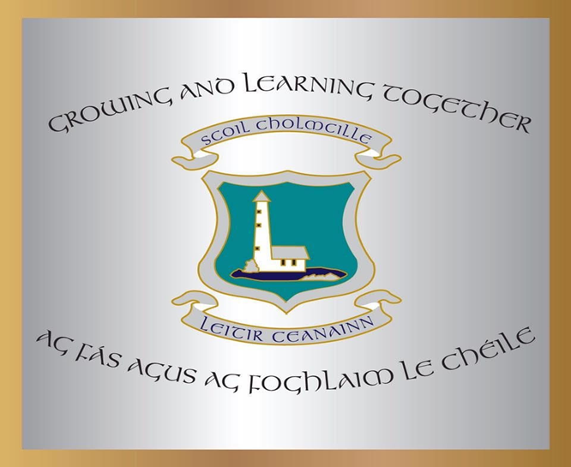

Junior Infant

ENROLMENT FORM

Pupil’s Name: _________________

