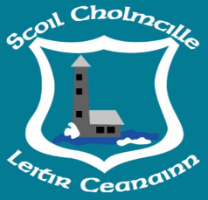
Growing and Learning Together
Whole School PE Plan
2020/2021
Year 1
Term 1 | Month | September | October | November | December
 | Strand | Athletics | Games- Basketball | Athletics | Gymnastics
 | FMS | Running | Throwing | Hopping | Balancing
Term 2 | Month | January | February | March
 | Strand | Gymnastics | Dance | Dance
 | FMS | Landing | Skipping | Side- stepping
Term 3 | Month | April | May | June
 | Strand | Games / Soccer or Gaelic | Athletics/Games | Outdoor / Adventure
 | FMS | Catching /Kicking | Jumping for distance | Walking

