Hi boys,
Only 3 weeks to go! I am looking forward to seeing you all on graduation day. I know it’s not what you expected but it will still be special. Work wise, just do what you can. You have the transition booklets home now to work on. This will help you prepare for secondary school. Remember to contact me at scmrsmcclafferty@gmail.com if you have any questions and send me on some/all of what you have completed. Keep at it!
Keep Safe
Mrs Mc Clafferty
Maths Group (9.20-10.00am)
We are moving on to multiplication with hundreds this week. Watch this video to remind you and there are also examples in the book:
https://www.youtube.com/watch?v=FJ5qLWP3Fqo
- Busy at Maths: p. 140, 3-7, p.141, 1-6. p. 142, 2-6 & p.143 problem solving. Use this video to help https://www.youtube.com/watch?v=RVYwunbpMHA

- Revise all tables!! https://www.topmarks.co.uk/maths-games/hit-the-button
If anyone needs answers just e mail me. Remember - Use this link https://my.cjfallon.ie/dashboard/resources if you do not have the book.

English Group 2 (11.50-12.30)
Click on this link: https://www.literacyshed.com/the-egyptian-pyramids.html and watch the first video on Egypt.
Write a paragraph on what you think was happening in the video.
Skills Book p 116 - Revision : you may need to look back in the book for the answers, it’s like a treasure hunt!
P 117 – Read the steps slowly and carefully and then try to put them in the correct order, making sure they make sense.
P 118- Comparatives. E.g Kuba is tall, Egyras is taller but Mrs Mc Clafferty is the tallest!
If you do not have the book, use this link - https://my.cjfallon.ie/preview/index/26831/6
Read at Home – tell me about your favourite story in the book & why!
Library Book If you have no books at home to read, try to set up and account on https://www.oxfordowl.co.uk there are loads of free books to read, fact & fiction. I would recommend the grey or brown level to see how you get on. You can then go up/down level to find the ones you are able to read fluently!
Book Review Try to do your own book review and send it on to me if you can!
Spellings – see below

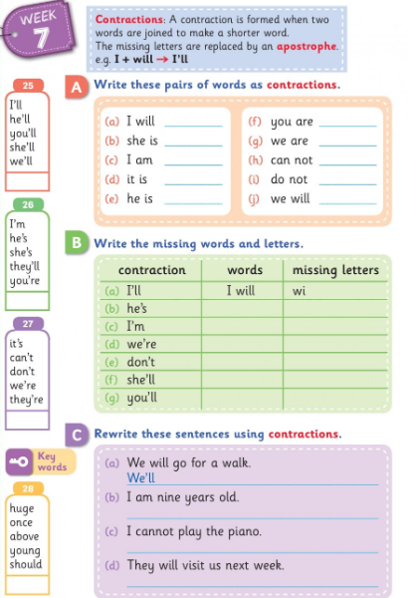

Maths (11.15) – M.M. (A menu of options to choose from)
We are now revising money. You will find this easy after working so hard in the school shop!
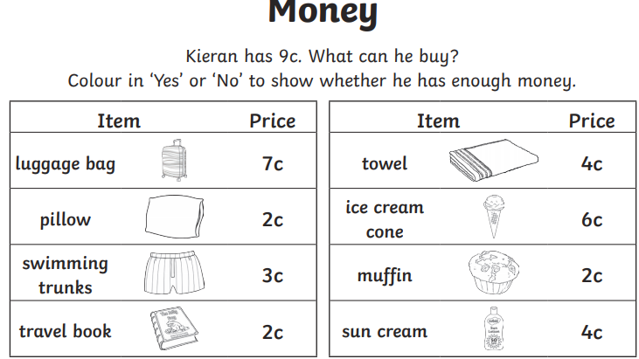

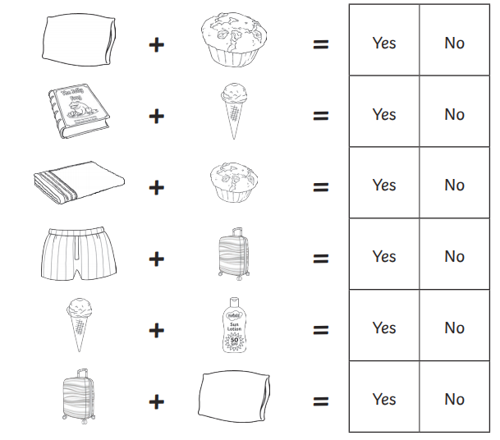
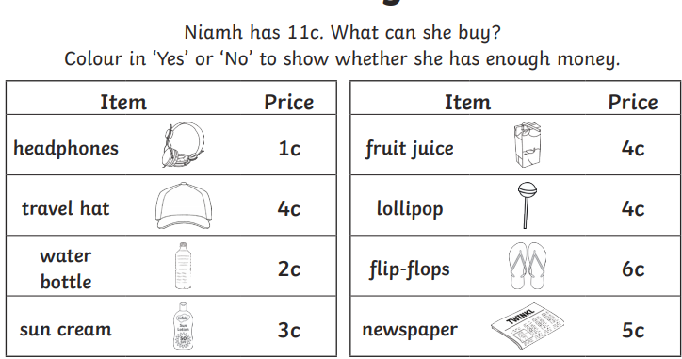
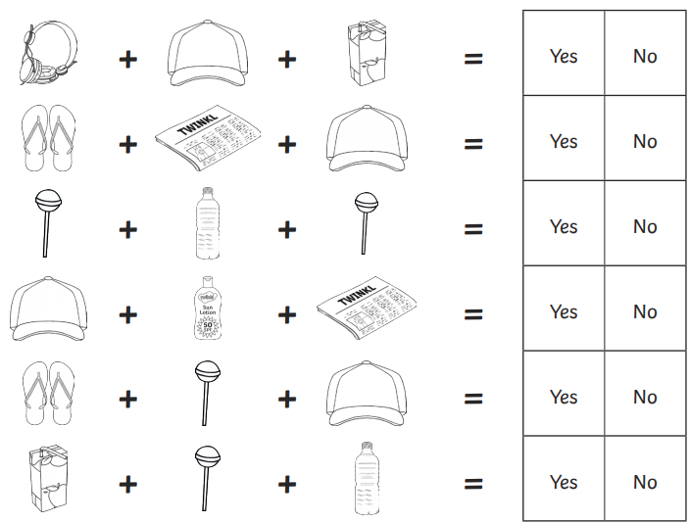

Revise times tables https://www.topmarks.co.uk/maths-games/hit-the-button

