Week June 2nd-5th:

Hello everyone,
I hope you and your families are all safe and well and tha you enjoyed the fabulous weather that we have been having. Thank you to all of you who have sent me on some samples of your work and thanks too, to the grown ups at home who have helped you to do so.
Below is a link for a suggested programme of work.
I love getting your emails . Remember you can send them to me at
scmrsshields@gmail.com. I would love to hear from you!

English:
Reading:
- Starlight combined reading and skills book: P 42: A Matter of Taste & Not so Fast Food. Please complete activities also.
(online at Folensonline.ie)

- Other reading group: see attached sheets at the end of this document.

For extra books to read online, if you wish, you can access 330 + books on Collins Big Cat eBooks at website below.
Collins.co.uk/pages/bigcat-ebooks
Follow instructions (additional link to Collins Connect) and register via the Teacher Portal.
Username: parents@harpercollins.co.uk

Spellings:
- Spell Well 2: Week 33: pages 68,69. Long u sound.
- Please put each word into a sentence and complete activities.

- My Spelling Workbook A: Unit 14: words with and, end. Pages 66,67.
- Put each word into a sentence and complete activities.

Written work:
Attached worksheet: Cloze test:

Grammar:
Alphabetical Order: Part 1:
Please see worksheet

Maths:
- Busy at Maths; Number patterns pages 140-143.
- You can use your 100 square to help you.
- Check out tutorials on mycjfallon.ie to help you with this topic.

Tables: Revision: +7, +8,
Math Magician online is a great way to practise.
Don’t forget your Daily 10 on Topmarks.co.uk

EAL Group:
Our learning theme is : Caring for my locality.( our surroundings)
Think about ways we can care for our locality… around our home, in the green area in your estate, the local park, the beach.
The importance of not dropping litter.

- https://www.twinkl.ie/resources/esl-resources –
This website has lots of vocabulary worksheets and flashcards for children to practise vocabulary about your locality.

www.nationalgeographic.com/kids is a great resource to learn about our world, plants and animals
Activity:
I want you to write about your locality, where you live and ways that you can take care of it. Draw a picture too!

As the weather has been so nice , now is a great time to revise the words for Summer. Use the apps listed below to help.
Activity:
Write a few sentences about what you have been doing in the beautiful weather we have had. You can draw a picture too.

Here are some of the APPS you can use:they are free!
Learn English Kids playtime
- another British Council app with fun songs, stories and games
Timmy's starting to read -
English language learning for children age 6 and younger.
Speaking pal English tutor -This is an interactive APP.
Monkey puzzle - games on elementary topics such as food, clothing, colours etc..
Learn English for kids by Talk English- introduces words one at a time with pictures.
Memrise - great for the 8 year old and the parents
Duolingo- a brilliantapp
This website has lots of vocabulary worksheets and flashcards for children to practise their familiar words. This link shows you some vocabulary for the Farmer and his tractor
https://readingeggs.co.uk/ There is a free trial for parents to access some simple english reading books.
https://www.barryfunenglish.com/ interactive games using familiar vocabulary.
Starfall.com: website which helps with reading and also has a talking library,
Grammarmancomic.com isa website with comics for reading, grammar and vocabulary skills.
Englishpage.com has good interactive exercises.

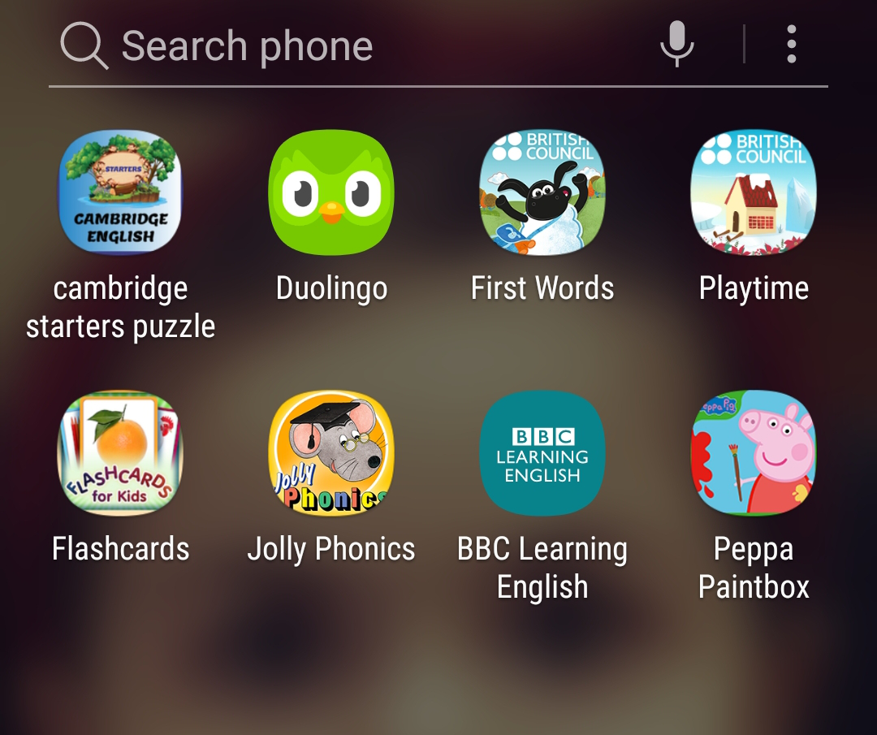

Reading for Tuesday June 2nd:

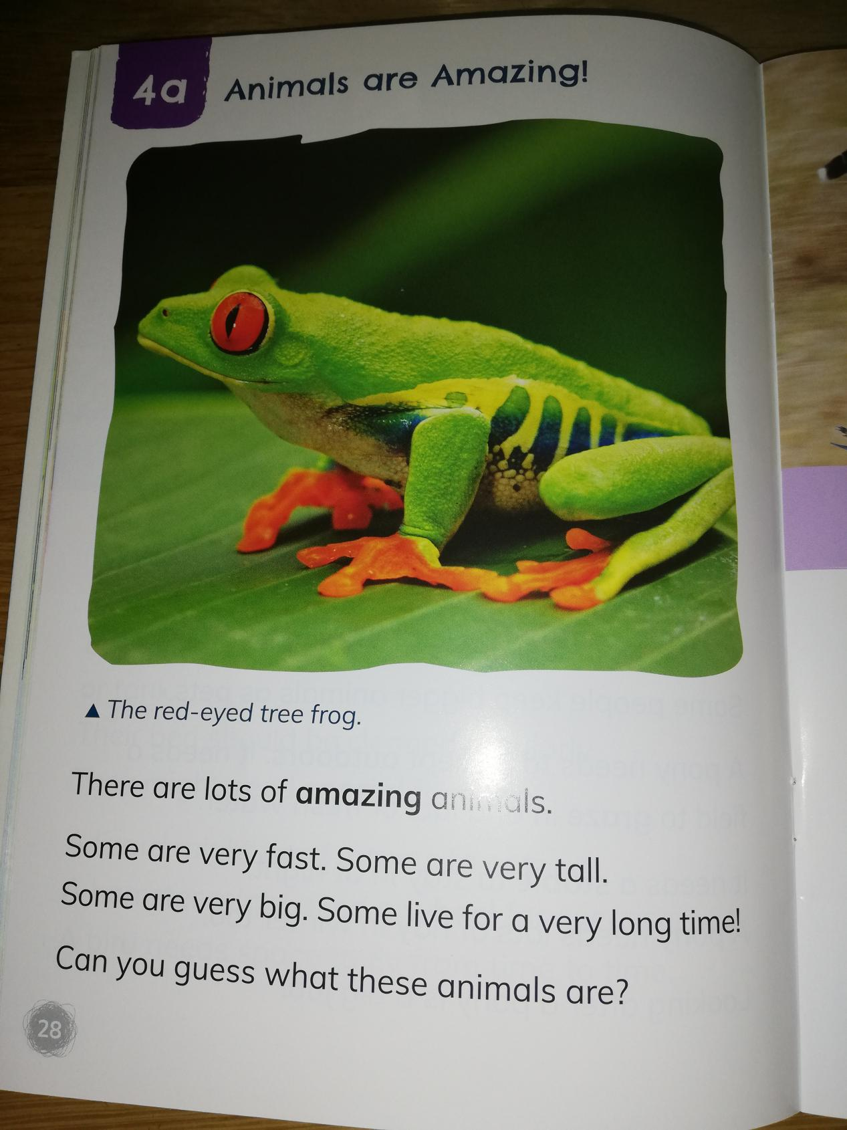

Reading for Wednesday June 3rd:

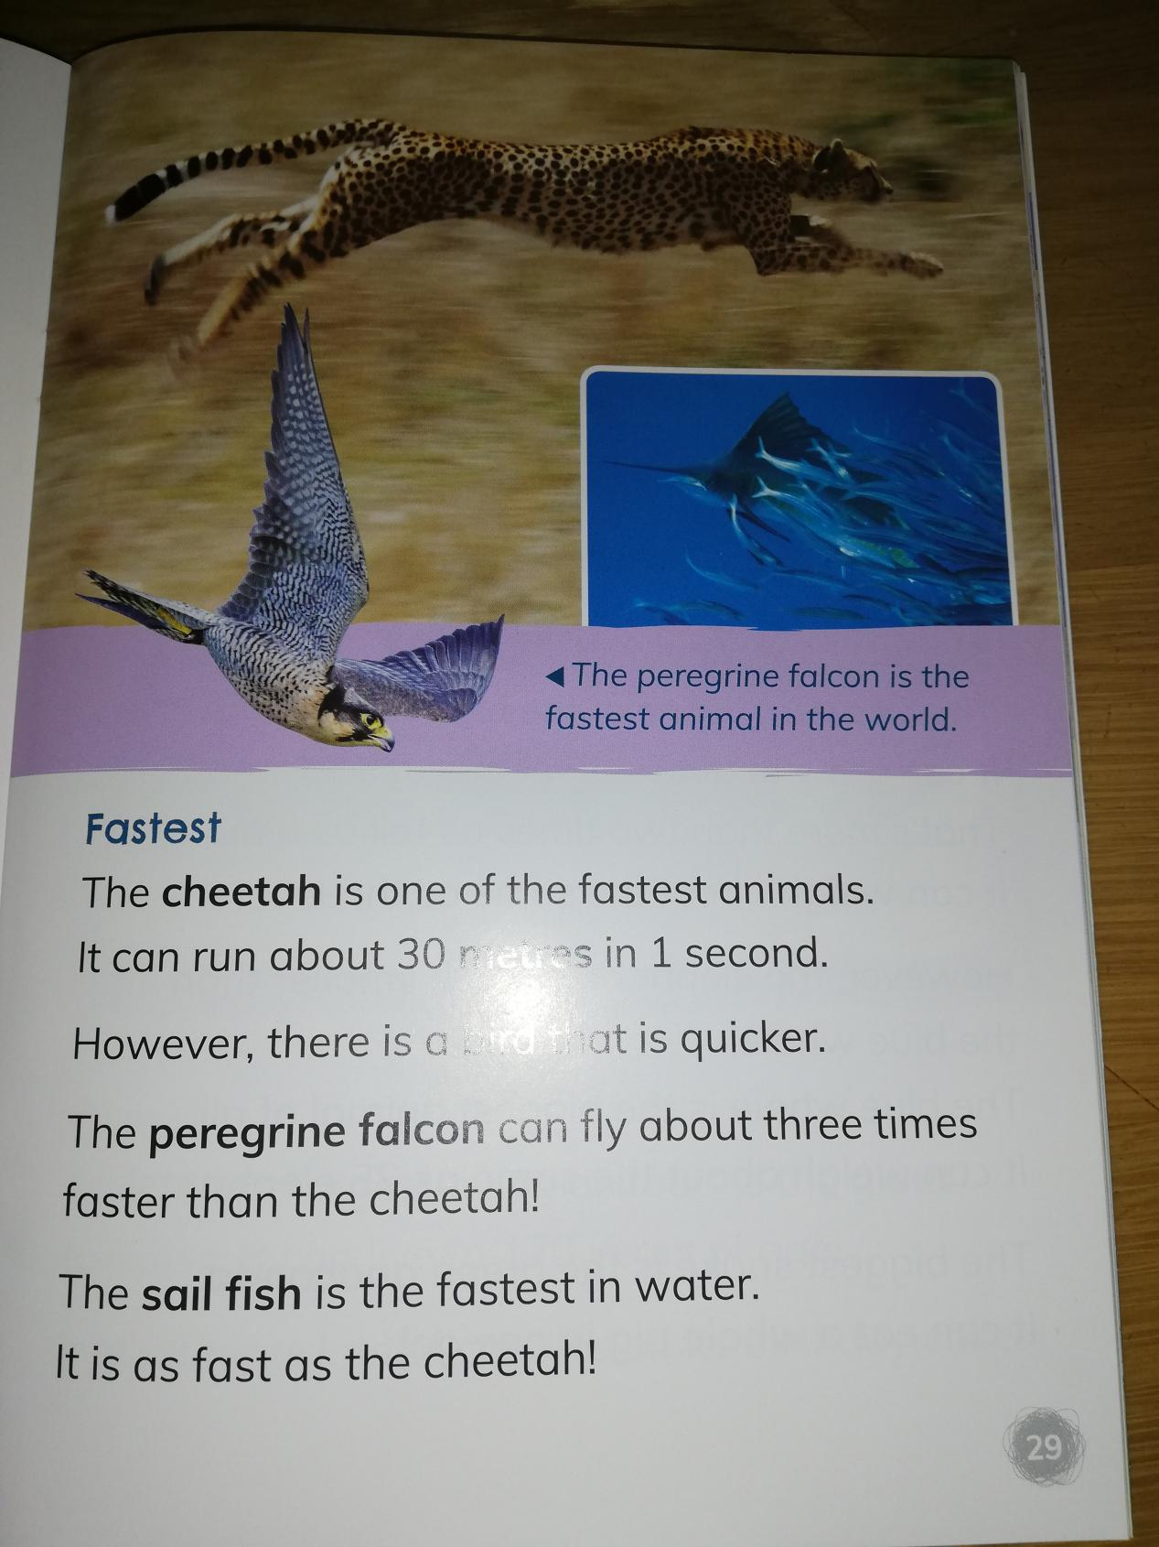

Reading for Thursday, June 4th:

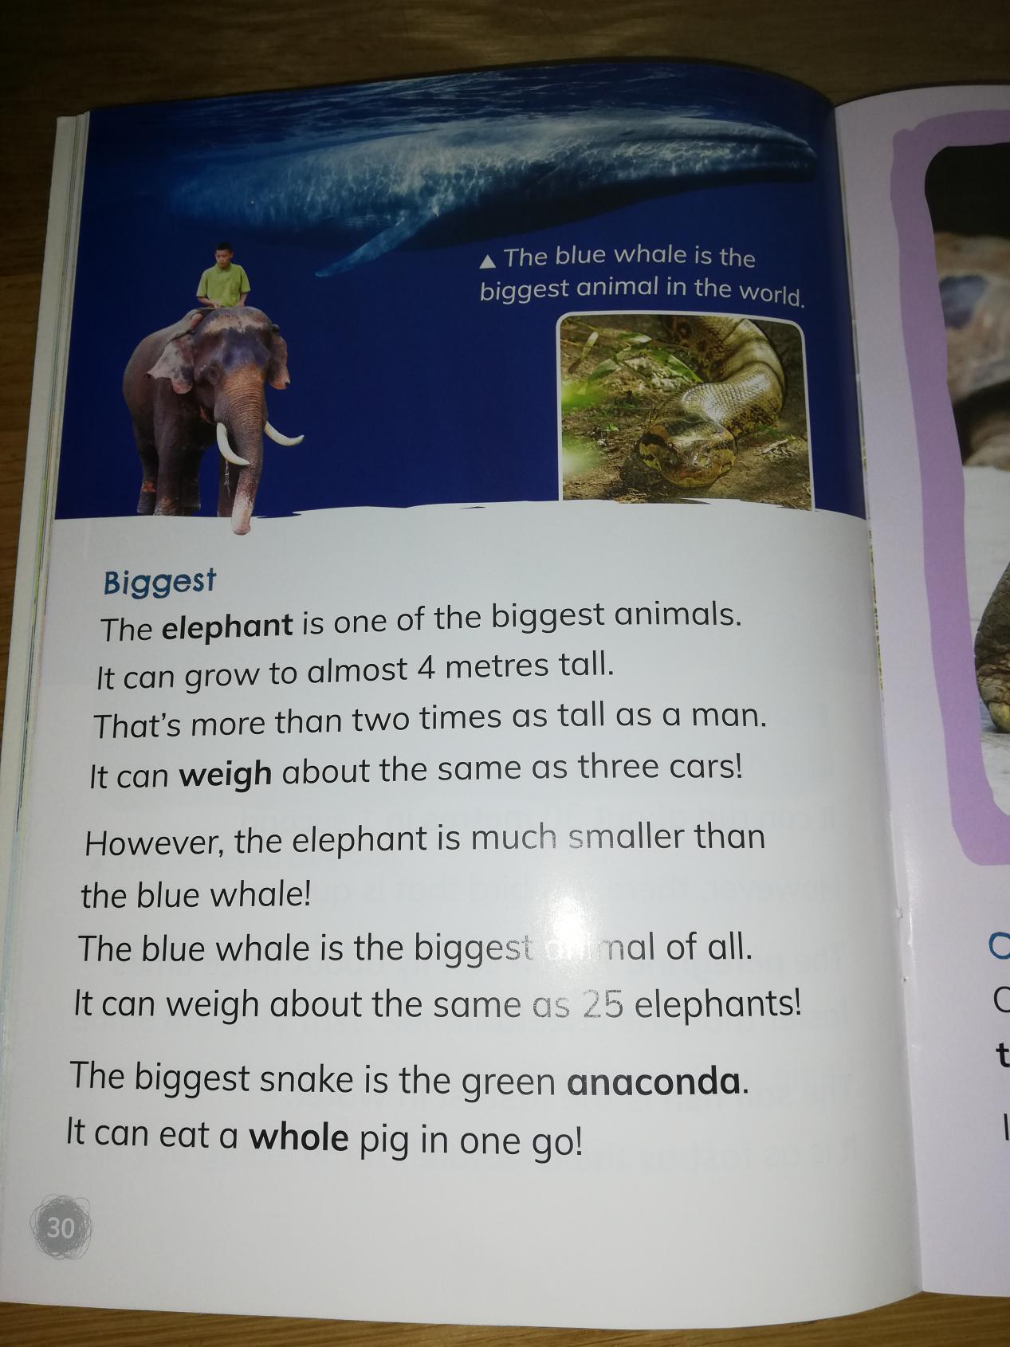

Friday, June 5th:

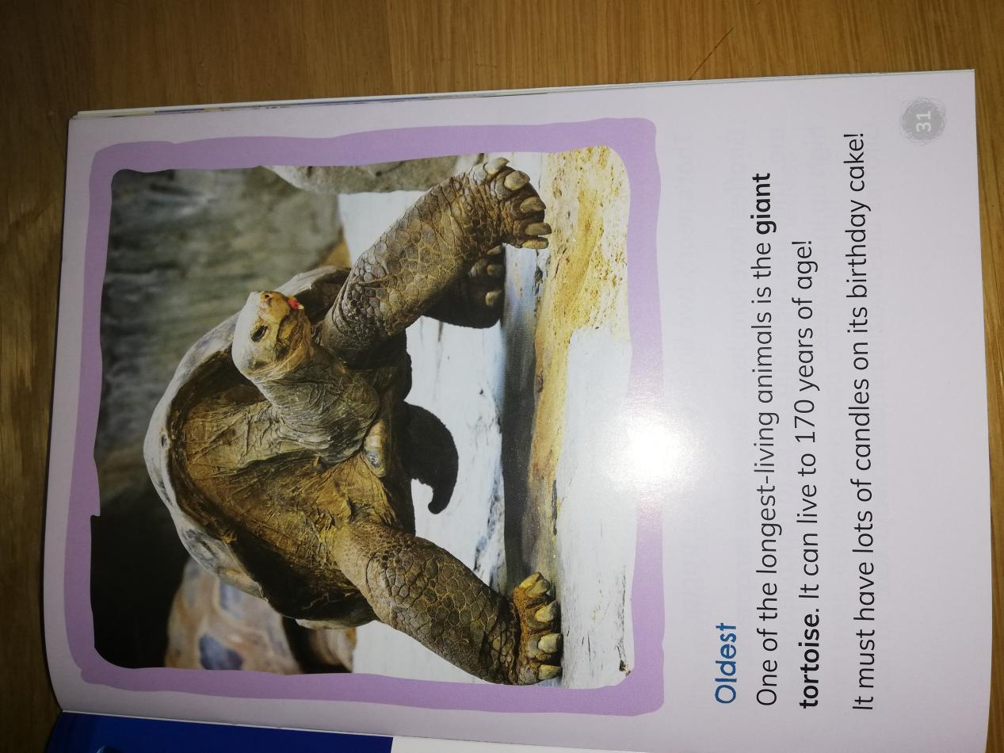

Cloze Test: Use the words in the word box to fill in the spaces. Only one word per space. Each word is used only once.

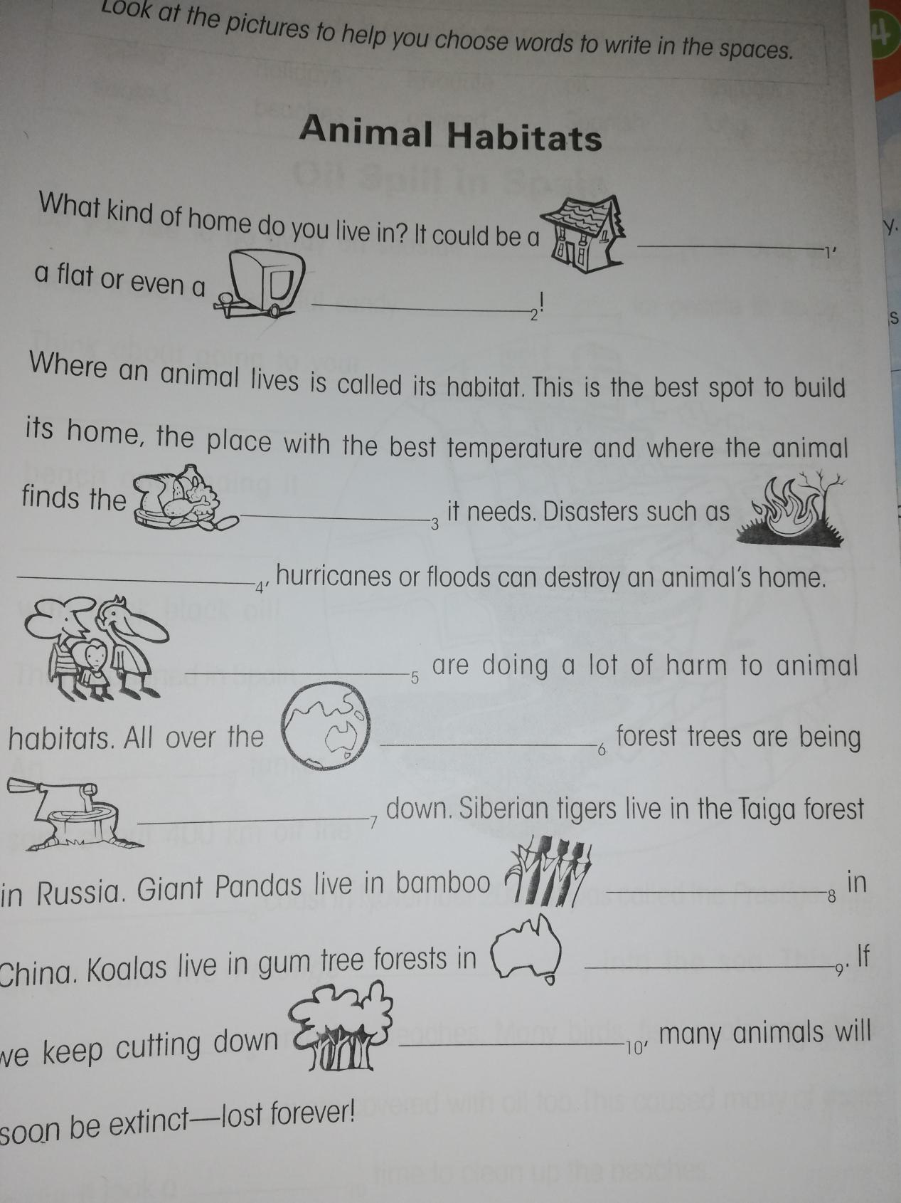

Grammar: Alphabetical Order:

