Hello boys and girls of 5th class,

We have made it to the final few days of the school year. It is hard to believe that it has been 3 months since we have all been together and we have missed you all very much. We know that it has been a difficult 3 months but we are extremely proud of you all and how much effort and hard work you have all put in at home with your school work. We loved receiving all your emails, photos and videos of all the activities that you did at home. We want to take this opportunity to thank you, your parents and your family for how great you all have been during this time and how well you adapted to the changes. It has not been an easy time but you have all been amazing. We know that are all must be looking forward now to a well deserved break and we hope you all have a great summer. Remember to stay safe.
We are really looking forward to seeing you all again in September.

As it is our final week of school we have decided to take the focus off school books. We have posted some fun activities that we hope you enjoy taking part in. Make sure to send us in some pictures/videos of you and your family doing some of the challenges. We would love to see them.
We have also added some links to virtual schools tour that we think you might enjoy.

Remember all Book Rentals must be returned this week to the school. They can be returned on Thursday 25th and/or Friday 26th between 10.00 am- 2.00 pm.
(5th class book rentals: Abair Liom, Busy at Maths, Unlocking SESE 5)

Stay Safe,

Ms. Collins and Mrs. Maguire

Maths Challanges

https://www.twinkl.ie/resource/t-n-252416-outdoor-maths-challenge-cards

https://www.twinkl.ie/resource/ni2-m-1-outdoor-learning-maths-investigations-ks2-activity-pack-

https://www.twinkl.ie/resource/t2-cfe2-m-196-ks2-take-it-outside-maths-challenge-cards

Scavenger Hunt ideas 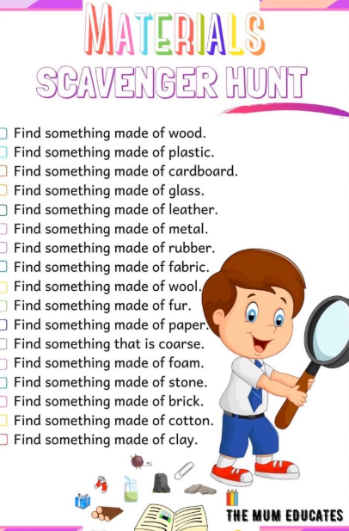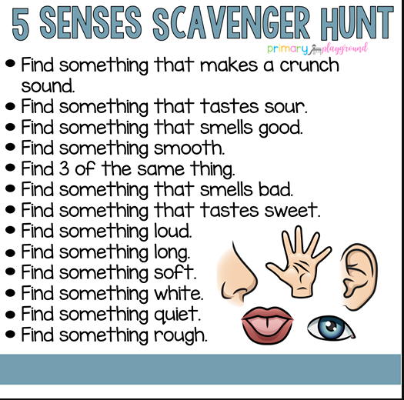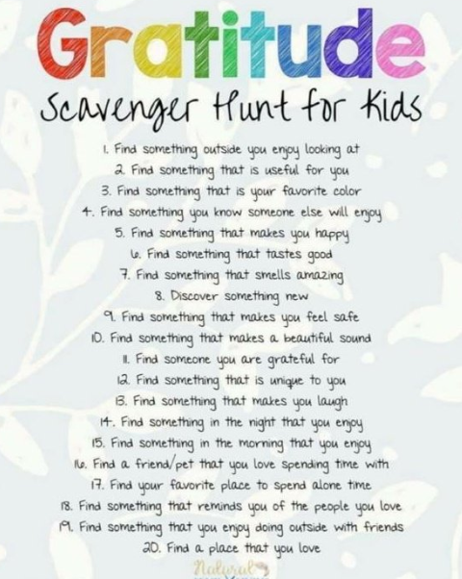

Fitness challenges

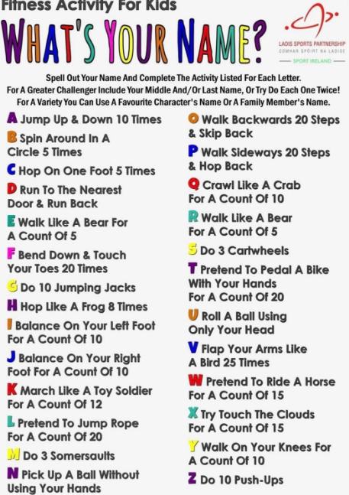

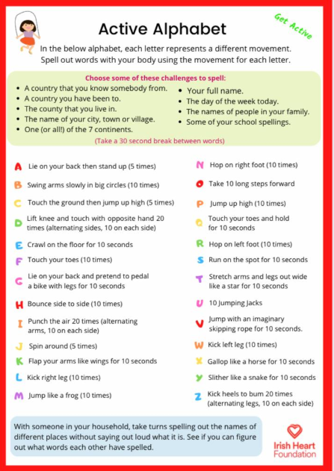

Vitual School Tour
Some wonderful place to visit and enjoy, In Ireland and around the world:
Dublin Zoo: https://www.dublinzoo.ie/animals/animal-webcams/

Animal Farm: https://www.youtube.com/watch?v=Hg2ZX0PF-jI

African Safari: https://wildearth.tv/kids/

Aquarium of the Pacific: http://www.aquariumofpacific.org/exhibits/webcams

Monterey Bay Aquarium: https://www.montereybayaquarium.org/animals/live-cams

National Gallery of Ireland: https://www.nationalgallery.ie/virtual-tour

Áras an Uachtaráin: https://president.ie/en/explore-visit/interactive-tour

Natural History Museum Dublin: https://www.cliste.ie/natural-history-museum-virtual-tour/

Dublin Rising 1916-2016: https://dublinrising.withgoogle.com/welcome/

Harry Potter Tour: https://youtu.be/9gxVWPvfyLE

Le Louvre: https://www.louvre.fr/en/visites-en-ligne

The American Museum of Natural History: https://www.amnh.org/

