8th June 2020

Hello everyone,
We hope you are all keeping well. We are very impressed with all of the work that has been sent in so far and with just a few more weeks until the summer holidays, we encourage you to keep up the good effort.
The weekly plan of suggested work is below; just click on the blue link.
Remember to do your best and to email us some pictures of your work throughout the week. We love to hear from you all.

Email addresses:
sc5thclass@gmail.com (Mrs Maguire and Ms Collins)
scmrscannon@gmail.com (Mrs Cannon)
scmissmctaggart@gmail.com (Miss McTaggart)
scmskeys@gmail.com (Ms Keys)
scmrkavanagh@gmail.com (Mr Kavanagh)
scmrcrossan@gmail.com (Mr Crossan)

Try to tune in to the ‘Home School Hub’ on RTE2 every day at 11am and ‘Cúla4 ar Scoil’ on TG4 every day at 10am. Keep working on your Covid19 Time Capsule worksheets!

Stay Safe,

Mrs Maguire and Ms Collins.

Suggested Programme of Work 5th Classes 8th - 12th June 2020

Math

- Busy at Maths Revision ‘2 -D shapes’ P58 Q1, & Q4. P59 Q1 & Q2. pg. 60 Q1 &Q2.
- Master Your Maths is now complete…well done! Look back over the chapters; if there’s anything you missed due to absences try to catch up over the coming weeks. If you have completed any weeks that you would like the answers to, send us an email and we will forward you on the answers.
- Tables - Continue revising all multiplication and division tables. Play ‘hit the button’ on Topmarks throughout the week to improve speed and accuracy.
- Have a go at some of these brainteasers! https://brightside.me/wonder-quizzes/17-challenging-brainteasers-for-kids-that-will-stretch-your-brain-193205/

Math Websites:
www.topmarks.com
www.ixl.com
www.nrichmaths.org
www.mangahaigh.com
www.khanacademy.org
www.mathsplayground.ie
www.twinkl.ie

English

- Above the Clouds Reader - Revise the story ‘The Accident ’ P224.
- Above the Clouds Portfolio P114 -117. Complete all activities.
- Spellbound Week 33 P68- 69 - Complete all exercises. Revise all spellings from Week 27 P44 - Complete sentences & thesaurus work.
- Novel - Continue to read 3 to 5 pages per day, continue to complete character profiles, chapter summaries, illustrate your favourite scene and make predictions. When the novel is completed, write a book report.
- Continue with Time Capsule booklet.
- Free writing - Write some stories or poems of your own!
- Imagine you are Linda Brown (see History assignment). Write a diary entry about your fathers case and say how you feel about the school system.
- Write your own acrostic poem using the word SUMMER
- Poetry - Above the clouds pg 223‘The sorcerer has cursed me’. Read poem and answer the following questions:
- What is the mood of the poem?
- Has the sorcerer changed him?
- Can you think of another word for sorcerer?
- Is this a serious or humorous poem? Why?
- Do you think this is a good title for the poem? Can you think of another title for the poem?

Literacy Websites:
www.twinkl.ie
www.freebooksy.com
www.worldofdavidwalliams.com
www.booktrust.org.uk
https://home.oxfordowl.co.uk
www.rte.ie/player

Gaeilge

- Abair Liom is complete, well done! Work assigned is revision of chapters already covered.
- Abair Liom P150 - Activity I Scíobh smaointe na gcarachtar (write the characters thoughts) illustrate and learn.
- Rírá - P62&63 ‘Troid sa chlós’ - Complete all activities.
- Tune in to ‘cúla 4 ar scoil’ at 10am on TG4 every day to keep improving your Irish!
- Try some briathar/ainmfhocal (verbs/nouns) games on this website! https://www.seideansi.ie/ainmfhocal-briathar.php

Gaeilge Websites:
www.focloir.ie
www.cula4.com
www.rte.ie/player
www.teanglann.ie
www.seideansi.ie

History

- Unlocking SESE ‘Young History Makers’chapter 20 pg. 124 - 129
- Read about three young people who played an important role in History
- Describe the actions and feelings of these young people as they made History
- Describe the motivations and attitudes of these people
- Complete think and discuss activities on pages 125 & 127

Geography

- It is World Ocean Day on the Monday 8th June. This year’s theme is Innovation for a sustainable ocean. To learn more click on the link : https://www.twinkl.ie/resource/t-cfe2-t-2545577-world-oceans-day-powerpoint
- You can also go to the world ocean website on https://worldoceansday.org/resources/?topic=all&type=all&language=all
- Think of ways in which you can reduce your use of plastic or recycle what you do use
- How could you use less energy to help reduce global warming?
- Design a poster to display in a room of your home to encourage the members of your family to recycle
- The example below shows how you can encourage someone to recycle in the kitchen.
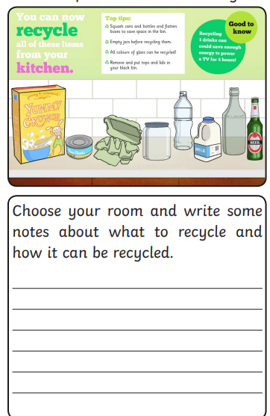

Science

- Make your own ocean waves in a jar
- You will need:
- A jar or plastic bottle
-Vegetable oil or baby oil
- Blue food colouring
- Water
- Fill your container 1/2 way with water and add as much blue food coloring as desired.
- Fill the rest of the container up with baby oil or vegetable oil. Try and fill the container as full as possible, reducing the amount of airspace that will be left after you screw on the lid or cap.
- To make a wave tilt and gently shake your ocean in a bottle! Watch the wave action in your sea.

- Ocean waves are created by energy moving through the ocean water. Most of the time, the energy comes from wind blowing on and disturbing the surface of the water. Other things cause ocean waves too such as the gravitational pull of the sun and the moon. This causes tidal waves or tides! When you move the bottle, you’re seeing energy move through the water to make waves, just like out in the ocean
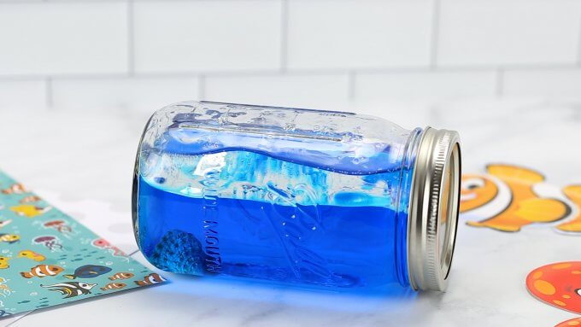

Art
- Salt Dough Starfish
- You will need :
- 2 cup of flour
- 1 cup of salt
- I cup of water
- Baking tray
- a toothpick
- In a large mixing bowl, combine the flour, water, and salt and mix well.
- Form your dough into a small golf ball sized piece, break into 5 pieces and roll into log shapes.
- Stick the 5 log pieces together to make a star.
- Smooth out the star and use a toothpick to make a line into each star arm
- Use the toothpick to poke everywhere around the line indents on the star.
- Leave the salt dough starfish to air dry. Decorate with paint

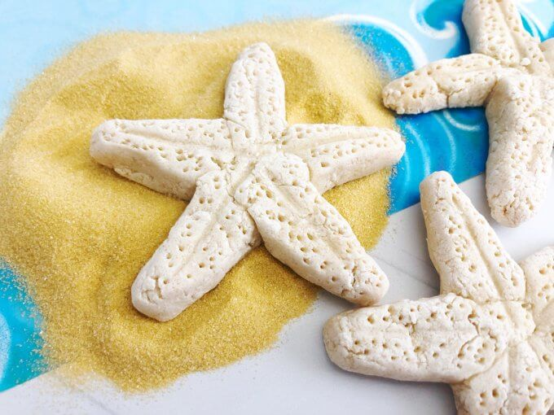

PE/ Wellbeing

- Continue to do at least 30 minutes of exercise every day!
- Also try some of the mindful activities suggested in the links https://positivepsychology.com/mindfulness-for-children-kids-activities/ and www.pdst.ie/primary/healthwellbeing/relaxationandself-regulationtools
- Practice some yoga poses with Twinkl! https://www.twinkl.ie/resource/t2-t-863-ks2-yoga-poses-powerpoint-
- Check link posted for obstacle course challenge

PE Websites:
www.gonoodle.com
www.rtejnr.rte.ie (10@10)
‘PE with Joe’ every morning at 9am (www.youtube.com)

Week Beginning 08/06/2020

A letter from your teachers ~ Mrs. Cannon & Miss McTaggart
Dear Pupils and Parents,
We are now very close to the holidays, with only two and a half weeks left in this most unusual of school years! It can be hard to keep the work going at this stage of the year, especially when the weather is very good but we want to encourage you all to do your best, just for a few more weeks! If this were a race you would now be able to see the finishing line and that’s the time to keep going! Thank you for all the work that you have been sending in. Please keep it up!
We have listed some new work for you for this week. Same as always; just do your best and of course you may get help from home. And remember we are here to help you too! We would love to see more of your work this week to see how you are getting on. Please send us photos of 2 or 3 pieces of work that you complete during the week by email if you can. Remember to tune into the SCHOOL HUB on RTE 2 every morning at 11.00am if you get the chance.
You can still find all the text books on line on the CJ Fallon website at www.cjfallon.ie if necessary and we have listed below the directions you need to reach them for Maths and English.
Please send the work to both of us at:
scmrscannon@gmail.com and scmissmctaggart@gmail.com
We look forward to hearing from you this week and thanks to all of you who have sent us some great work already! Keep it up! You’re doing great!
Keep safe and do not forget to give a helping hand at home!
Best regards,
Mrs. Cannon & Miss McTaggart

This is the work for Mrs. Cannon’s & Mrs. McTaggart’s English Classes:
(This work is for the children who work on Spellbound 3, Wordwise 3 and Ready to Go!)

To get into your SPELLBOUND 3 / WORDWISE 3 / READY TO GO! (Rainbow SERIES) books on line just type in www.cjfallon.ie and then select PRIMARY, 3rd CLASS, ENGLISH, SPELLBOUND 3 / WORD WISE 3 / RAINBOW SERIES. Once the book is listed click on the eye shape under ACTIONS and then enter your name, email and Student/Parent and then tick I Agree….and you are ready to go!

English Spelling ~ SPELLBOUND 3: (Revision Week)
- Pick 5 words from the box in Exercise 1 of WEEK 32 of your SPELLBOUND 3 and put these words in interesting sentences of your own.
- Learn the spellings in the box on Exercise 1 and maybe you could get someone at home to give you a spelling test on Friday?
- Complete exercises 1-3 in your books/copies (if you do not have your books.)

English Reading:
Keep up your reading. Read a little every day or read a story for your brother/sister at home. This website with eBooks has lots and lots of choice. If you wish you can tell/write a summary of one of these stories and send it to us.
https://www.oxfordowl.co.uk/for-school/oxford-owl-ebook-collection
Choose the age/level/series of reader you would like. You can just copy and paste this address to get started. Enjoy!
From your reading book READY TO GO! read Mr Penguin and the Lost Treasure on page 192 and look up some of the new red words in your dictionary. Practise reading it out loud taking a pause when you see a comma or full stop.
English Writing: READY TO GO!
After you have read Mr Penguin and the Lost Treasure try Exercises A, C, D and E.

English Writing: WORD WISE 3
This week we will move onto The Great Adventure Day on page 82. This passage is all about the fun activities that visitors to Activity Land can choose. Read all the information carefully before completing exercises A, B, C and D. On page 84 you will look at prefixes. A prefix is a group of letters put at the beginning of a word that usually changes its meaning e.g. unhappy, unable or replay. Look at the examples and complete exercises A, B, C and D.

Maths Work and Activities for Mrs. Cannon’s/Ms. McTaggart’s Maths Classes:
Tables: This week we would like you to learn your division tables for 3 and 6. (Remember! These are actually the same numbers as multiplication but written in a different order eg. 2 x 3 = 6 and in division 6 ÷ 3 = 2 and so on!) Get somebody at home to ask you your tables. You could write them out to help you to practise! To practise your tables and play other maths games try this address and choose the Times Tables option:
topmarks.co.uk/maths-games/hit-the-button

For the Pupils on BUSY AT MATHS 4:
To get into your BUSY AT MATHS on book on line just type in www.cjfallon.ie and then select PRIMARY, 4th CLASS, MATHS, BUSY AT MATHS. Once the book is listed click on the eye shape under ACTIONS and then enter your name, email and Student/Parent and then tick I Agree….and you are ready to go!

Chapter 27 Length ~ Pages 133-137

We hope that you will enjoy this chapter. Before starting each activity, make sure that you look carefully at the example first. It is fine to get help at home with anything you find difficult to do on your own. If any of these questions are too hard (even with help at home) just do the questions you can do. Remember Length is measured in centimetres (cm), metres (m) and kilometres (km). There are 100 cm in a metre and a 1,000 metres in a kilometre. So it you are asked for ½ a metre it is ½ of 100cm and so that is 50cm. So one quarter of a metre is 25 cm and so on.

(Please remember to continue to practise counting different groups of real money that you have at home and to continue to practice saying the time a few times every day with someone at home.)

In Master Your Maths we would like you to go back to Week 4 and complete the word problems at the end of each day and from the Friday Test at the end of the book on Week 4. Try your best and draw pictures if it helps you to figure out the answers.

For the Pupils on BUSY AT MATHS 5:
To get into your BUSY AT MATHS on book on line just type in www.cjfallon.ie and then select PRIMARY, 5th CLASS, MATHS, BUSY AT MATHS. Once the book is listed click on the eye shape under ACTIONS and then enter your name, email and Student/Parent and then tick I Agree….and you are ready to go!

Chapter 30 3-D Shapes ~ Pages 161 ~ 165
This week we are moving onto Chapter 30. This chapter is all about 3 Dimensional Shapes which is what 3-D stands for. Remember we also have 2-D shapes which have no width like circles, squares, rectangles etc. Before starting each activity, make sure that you look carefully at the example first. Use your Maths copy to write out the answers to these questions. Please remember to number the answers clearly so that if you send this work to us we will be able to really see how you are getting on. It is fine to get help at home with anything you find difficult to do on your own.
For Master Your Maths we would like you to continue to go back over your book to complete any days that you may have missed during the year. Also you could double-check to see if all your Friday Tests have been completed.

