Week May 11th-15th

Hello everyone,
I hope you and your families are all safe and well. Thank you to all of you who have sent me on some samples of your work and thanks too, to the grown ups at home who have helped you to do so.
Below is a link for a suggested programme of work.
I love getting your emails . Remember you can send them to me at
scmrsshields@gmail.com. I would love to hear from you!

English:
Reading:
- Starlight combined reading and skills book: The Sahara. Page 30
(online at Folensonline.ie)

- Other reading group: see attached sheets at the end of this document.

For extra books to read online, if you wish, you can access 330 + books on Collins Big Cat eBooks at website below.
Collins.co.uk/pages/bigcat-ebooks
Follow instructions (additional link to Collins Connect) and register via the Teacher Portal.
Username: parents@harpercollins.co.uk

Spellings:
- Spell Well 2: Week 30: Revision. Pages 62,63
Pick 3 words each day from weeks 26-29 and write a sentence for eacg word.

- My Spelling Workbook A: Unit 12: ee words
Complete activities and put each list word into a sentence.

Written work:
Our News.
Attached worksheet: Cloze test: Dogs
Spellings activities and sentences.

Grammar:
Conjunctions.
Conjunctions are small words that join two small sentences together to make a longer sentence.
Some examples are: and , but, although, because.
Please see worksheet

Oral language:
Talk to someone at home about summer. Use can use these pointers to get you started: months of summer, what happens to the days, weather, changes in nature,summer hobbies, a day at the beach etc.
You can write a few lines and/or draw a picture to match.
Twinkl.ie is a wonderful resource to look at. There are lots of powerpoints and other resources about summer. These resources are free.

Maths:
Busy at Maths:
Revision ‘A Quick look back’ p. 121
- Busy at Maths – Rotations and angles p.122 & 123
- When two straight lines meet they form an angle.
- You can use lollipop sticks or straws to make big and small angles at home.
- A right angle is a quarter turn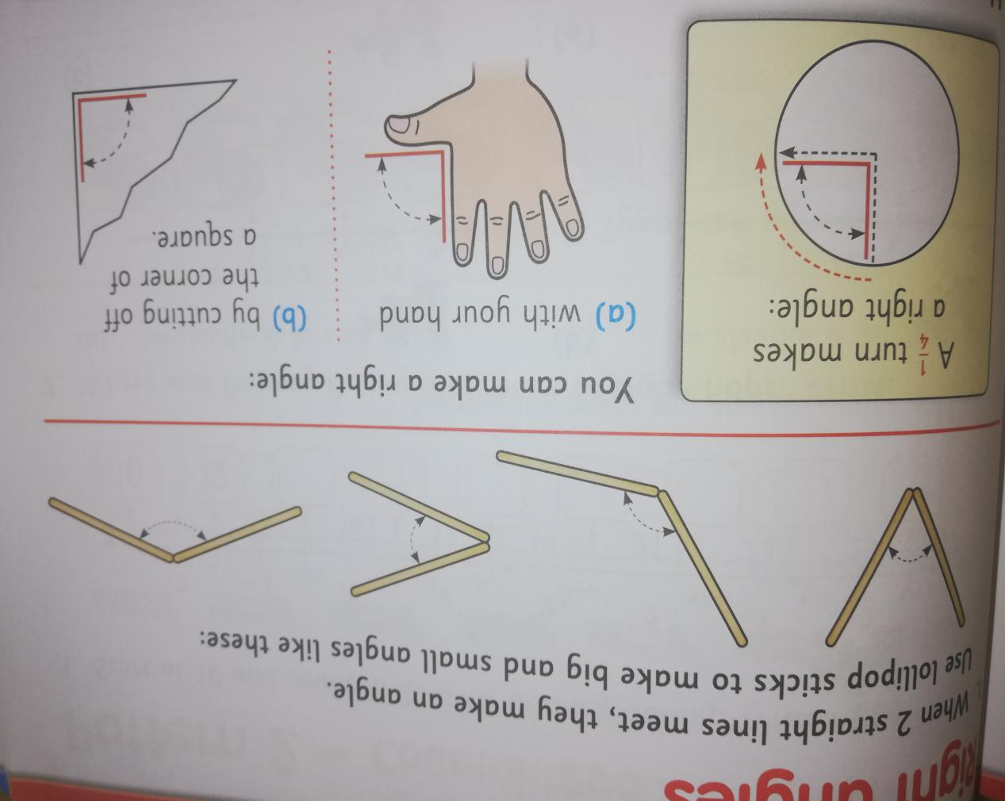
Can you make a right angle at home using straws/pens/paper? Can you find any right angles at home e.g. at the corner of a window, at a door.

- Master your Maths: Master Your Maths Week 28 p.60 & 61 & Friday Test on page 93

Tables: -12:
Math Magician online is a great way to practise.
Don’t forget your Daily 10 on Topmarks.co.uk

EAL Group: Theme : Summer.
Our learning theme’s this month are;
- Animals and Plants
- Time

Discuss changes in summer: months of summer, weather, change in length of day/night. Summer activities/hobbies.
Please refer to the following websites for worksheet,activities and powerpoints.
Twinkl.ie, Britishcouncil.org ,
Write a little story about summer or draw and label a picture showing some of the changes that happen in the summer.
Please also refer to the EAL section on the website homepage.

Farm Animals new vocabulary – learn the names of all these farm animals
- https://learnenglishkids.britishcouncil.org/sites/kids/files/attachment/flashcards-farm-animals.pdf

Use your copybook to write the names of the animals. Colour them in!
- https://learnenglishkids.britishcouncil.org/sites/kids/files/attachment/flashcards-farm-animals-bw.pdf
Play a Farm Animal word game;
- https://learnenglishkids.britishcouncil.org/word-games/farm-animals

Draw a picture of the Farm in your copybook or get an adult to draw. Read the sentences and colour the picture
- https://learnenglishkids.britishcouncil.org/sites/kids/files/attachment/colouring-farm.pdf

Here are some of the APPS you can use:they are free!
Learn English Kids playtime
- another British Council app with fun songs, stories and games
Timmy's starting to read -
English language learning for children age 6 and younger.
Speaking pal English tutor -This is an interactive APP.
Monkey puzzle - games on elementary topics such as food, clothing, colours etc..
Learn English for kids by Talk English- introduces words one at a time with pictures.
Memrise - great for the 8 year old and the parents
Duolingo- a brilliantapp
This website has lots of vocabulary worksheets and flashcards for children to practise their familiar words. This link shows you some vocabulary for the Farmer and his tractor
.https://www.twinkl.ie/resource/roi-t-2546171-exploring-my-world-grandads-farm-ebook
This link brings you to a book about the Little Red Hen. The Little Red Hen lives on the farm.comhttps://www.twinkl.ie/resource/tp-l-52275-the-little-red-hen-ebook Username:englishmisskeys@hotmail.
https://readingeggs.co.uk/ There is a free trial for parents to access some simple english reading books.
https://www.barryfunenglish.com/ interactive games using familiar vocabulary.
Big Bad Bug. The children use a magnifying glass to see some bugs in the garden. https://www.oxfordowl.co.uk/api/digital_books/1215.html The Little Red Hen. (This book is similiar to the one from the Twinkl website. You can practise your words).https://www.oxfordowl.co.uk/api/digital_books/1415.html

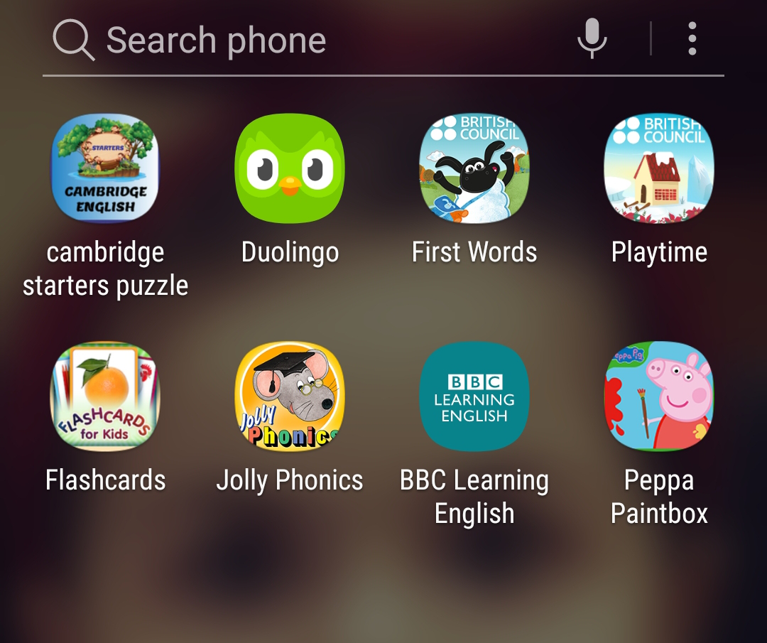

Reading for Tuesday and Wednesday.
(Half page on Tuesday, other half on Wednesday)
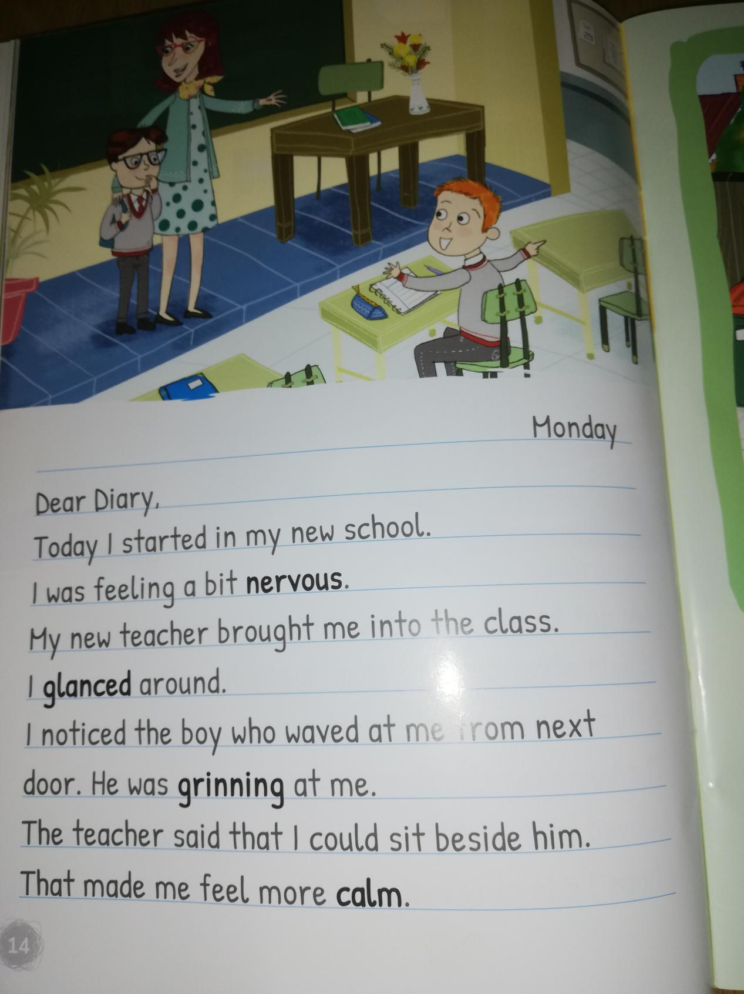

Reading for Thursday and Friday.
(Half page on Thursday, other half on Friday)
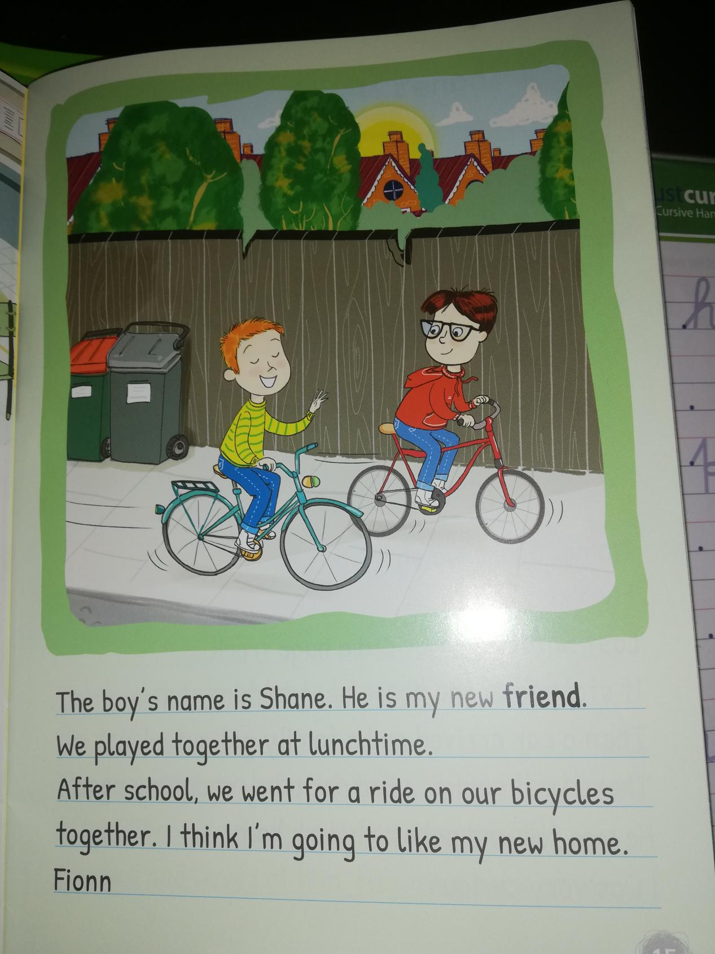

Cloze Test: Use the words in the word box to fill in the spaces. Only one word per space. Each word is used only once.
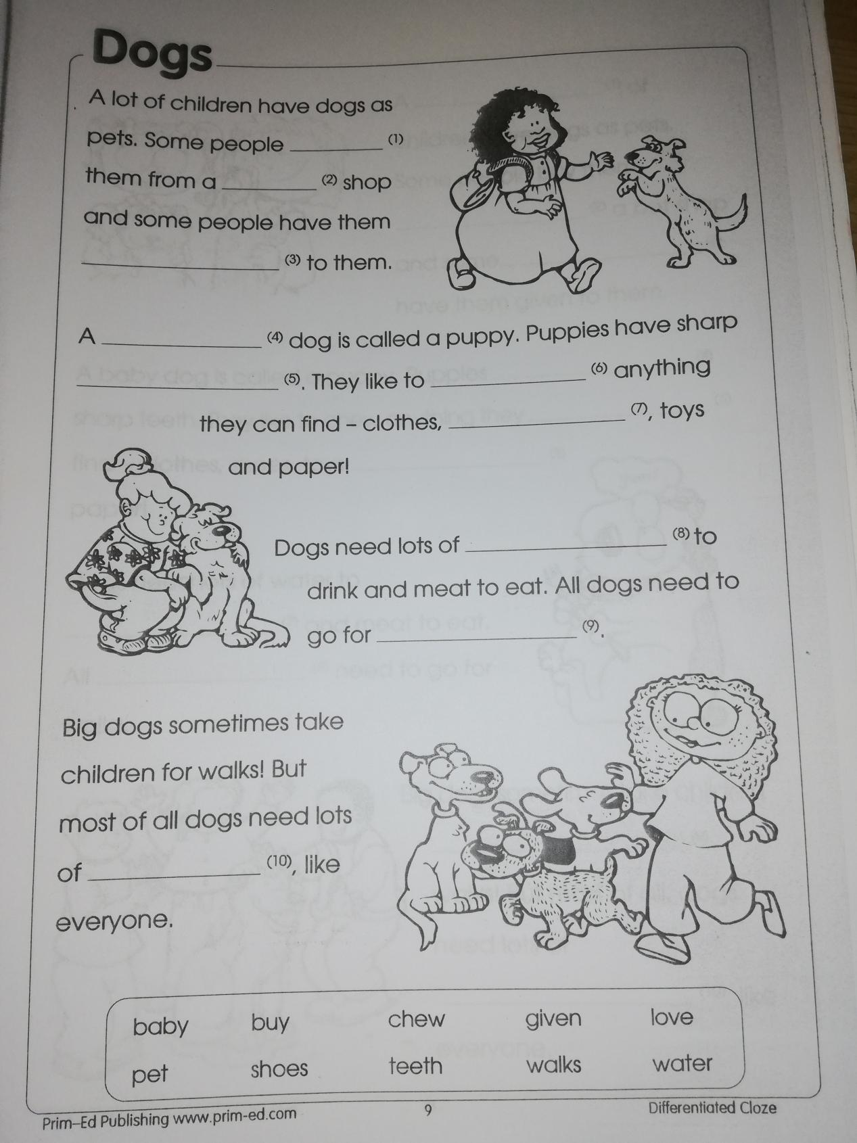

Grammar: Conjunctions.
A conjunction is a word that joins two smaller sentences together to make a longer sentence.

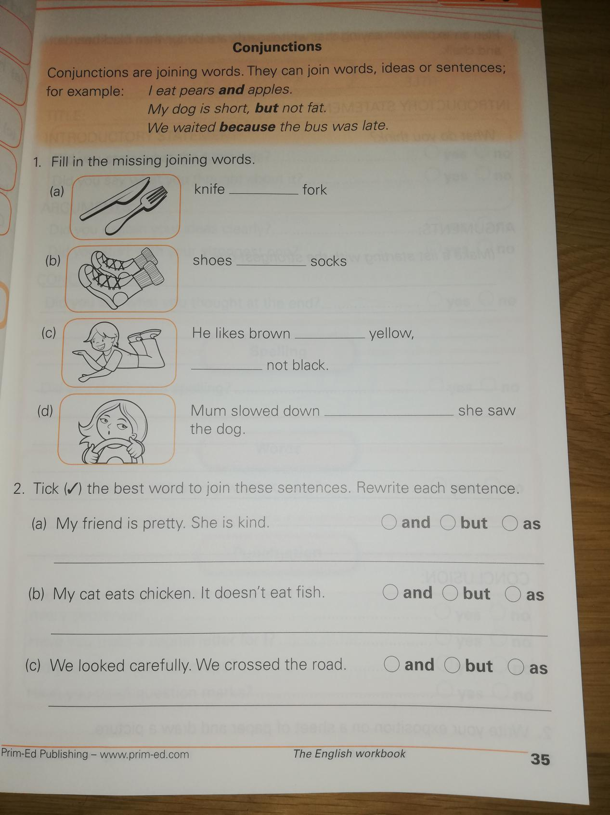

Phonics : ee