18th of May 2020
Miss McGill’s Group: We are learning to revise vowel sounds.
This week I would like the children to look back over what has been covered in the last few weeks in Phonics. Please spend time each day revising one or two of the sounds using the large posters.

Ask your child to:
- Sound out each word
- Circle the focus sound from the poster
- Sound out again and count the sounds on their fingers
- Copy the word sounding out as they write
If you have time:
- Choose a few words and draw a picture to match the word to show meaning
- Use some of the words orally in a sentence to show understanding
- Write the words in a sentence

ai
rain
main
stain
brain
pain
train
chain
Spain

fail
mail
nail
rail
sail
tail
snail
paint



rainbow

ay


day
hay
lay
say
may
play
tray
clay
stay
pray
delay relay

spray

ee
see
seen
been
green
Queen
feed
speed
need

week
feel
heel
sweep
feet
meet
sheet
sweet

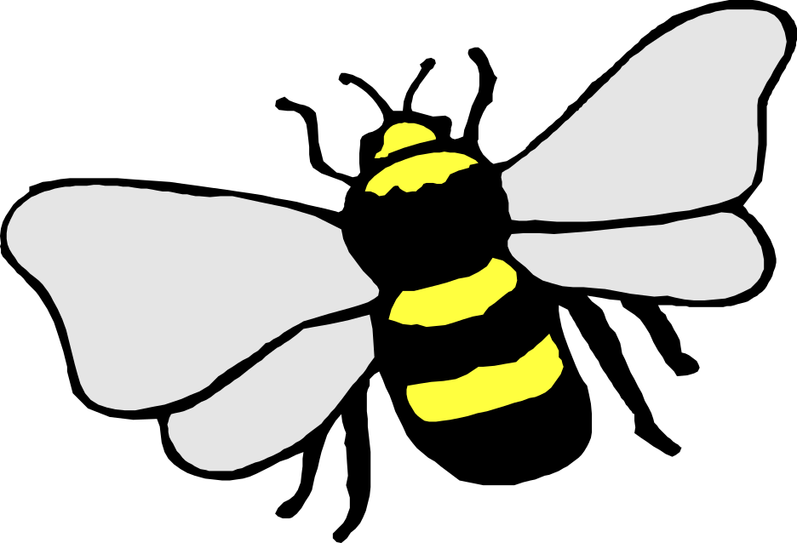

bee

ea
read
lead
beak
leak
weak
leaf
clean
heat

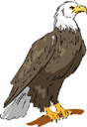
meal
heal
real
bean
lean
mean
teach
reach

eagle

igh

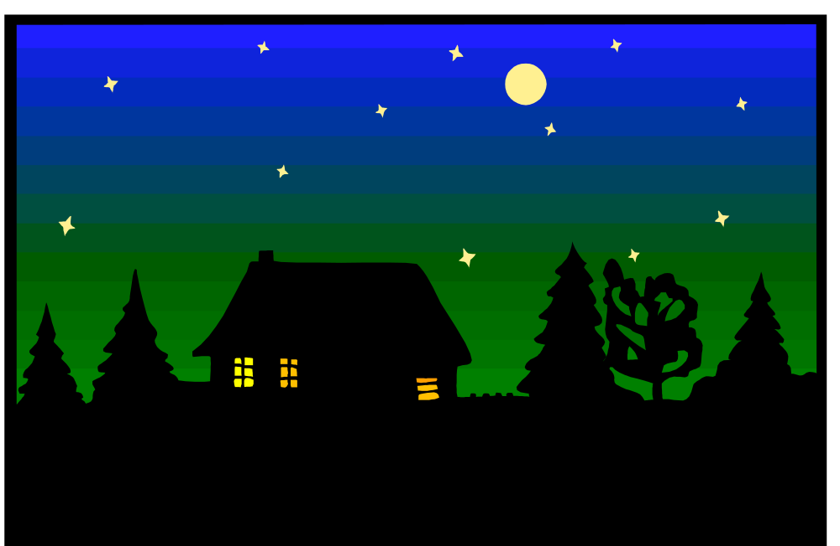
sigh
high
fight
light
might
tight
sight

rook

right
bright
fright
flight
delight
slight
height

night

-y
by
cry
dry
fry
fly
my
sty
shy

sly
sky
reply
occupy
July
rely
satisfy
multiply

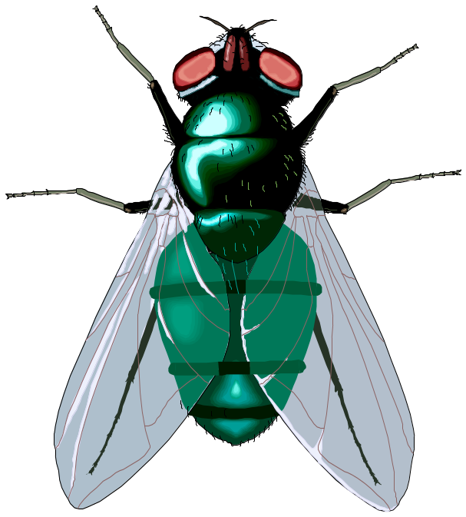

fly

ie

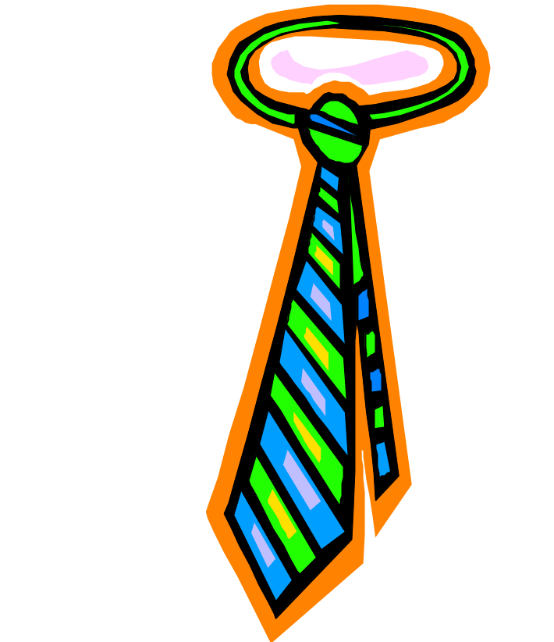

pie
tie
lie
die

If you eat pie in a tie you will lie down and die!

tie

oa

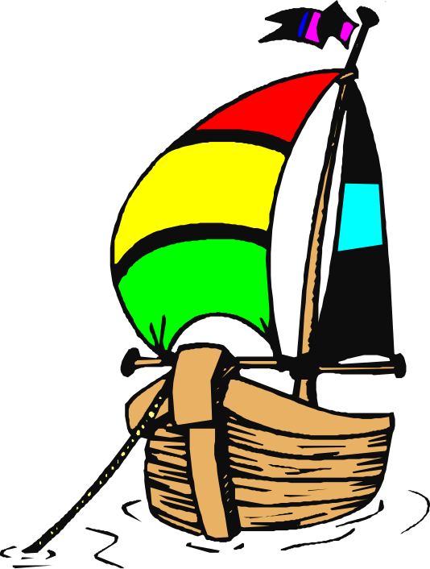
coat
float
goat
throat
load
road
toad
coach

toast
coast
roast
soap
moan
loaf
goal
moan

boat

ow

bow
low
mow
tow
blow
grow
show

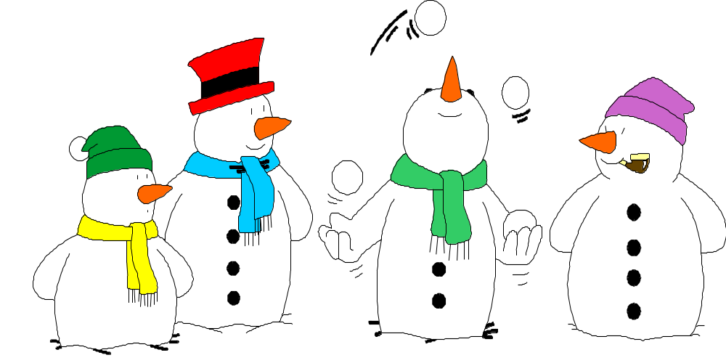
throw
slow
glow
flow
below
elbow
know
wool

snowment

oo
soon
noon
spoon
room
broom
boot
root
food
mood
zoo

cool
pool
stool
roof
tooth
smooth
proof
choose
loose
zoom



moon

ue

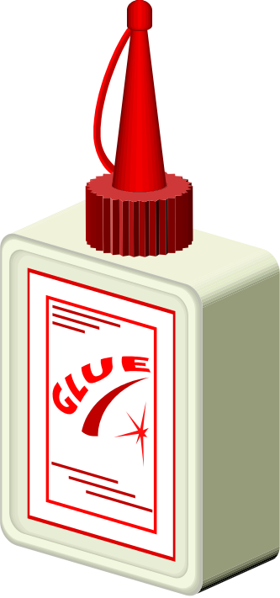

blue
true
clue
due
rescue
statue
tissue
value

glue

ew



few
new
stew
blew
flew
brew

grew
drew
chew
screw
threw
knew

crew

