05/05/2020

Hello everyone!
We hope you and your families had a lovely Bank Holiday weekend. Click on the blue link below to access the weekly plan of work and activities - Remember to do your best and to email us some pictures of your work throughout the week, if you can! We are very impressed with what we have seen so far. Well done!

Our email addresses are listed below:

Email addresses: sc5thclass@gmail.com (Mrs Maguire and Ms Collins)
scmrscannon@gmail.com (Mrs Cannon)
scmissmctaggart@gmail.com (Miss McTaggart)
scmskeys@gmail.com (Miss Keys)
scmrkavanagh@gmail.com (Mr Kavanagh)

Try to tune in to the ‘Home School Hub’ on RTE2 every day at 11am and ‘Cúla4 ar Scoil’ on TG4 every day at 10am. Keep working on your Covid19 Time Capsule worksheets!

Take Care and Stay Safe,

Mrs Maguire and Ms Collins.

Suggested Programme of Work 5th Classes 05/05-08/05

Math
(textbook available online at www.cjfallon.ie - click ‘student resources’ then filter to the title you require, making sure ‘online book’ is selected under ‘resources’.)

- Busy at Maths Shadow Book ‘Multiplication Word Problems’ P10 Q4-Q8.

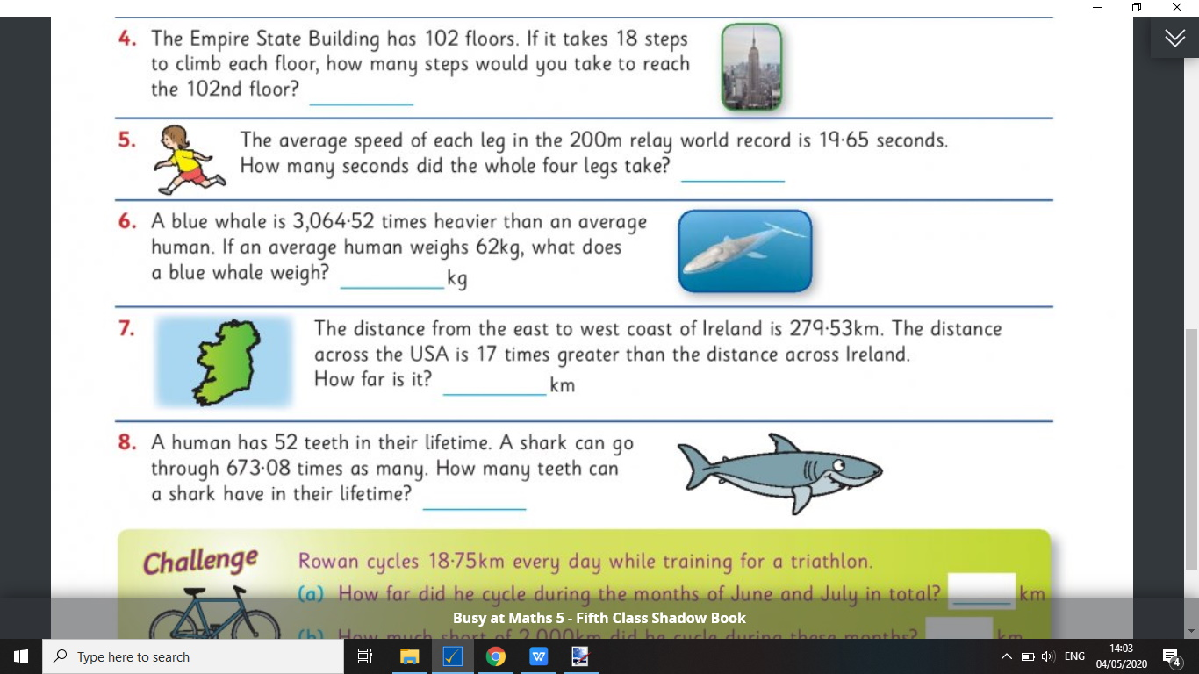

- Busy at Maths Shadow Book ‘Long Division’ P15 Q3&Q4.

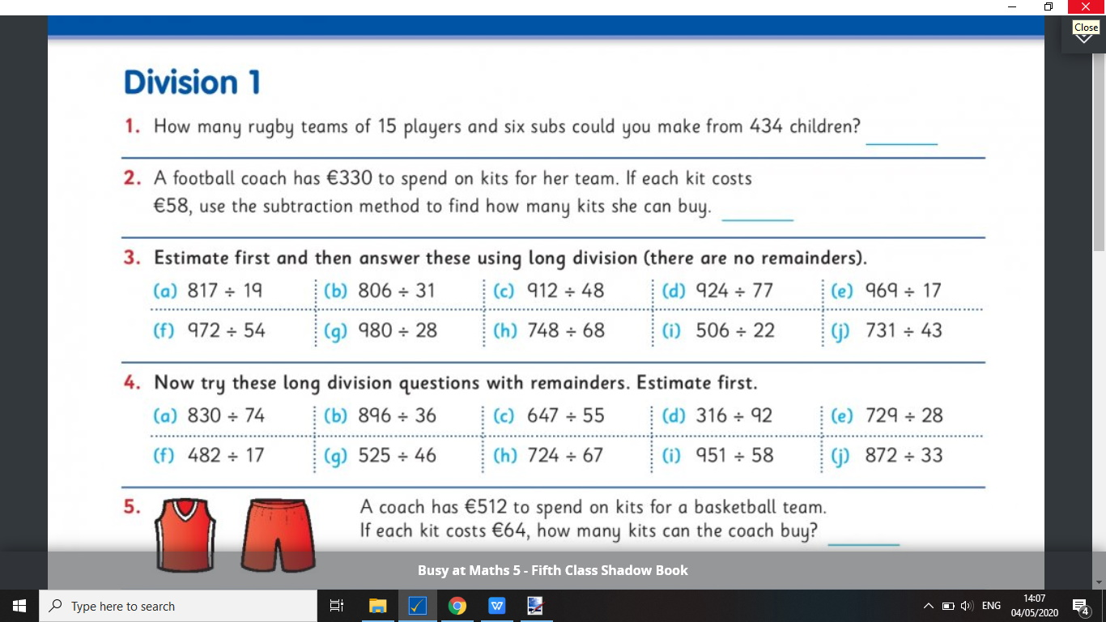

- Master your Maths (Week 29) - All answers will be posted to this blog on Friday for self correction.
- Home School Hub on RTE2 every morning at 11am (you can learn about time&speed on Thur 7th)
- Continue to revise all multiplication and division tables - Play the game ‘hit the button’ on the topmarks maths website (listed below).

Math Websites:
www.topmarks.com
www.ixl.com
www.nrichmaths.org
www.mangahaigh.com
www.khanacademy.org
www.mathsplayground.ie
www.twinkl.ie

English
(textbook available online at www.cjfallon.ie)
- Above the Clouds Reader P224 ‘The Accident’ - Read, retell, discuss.
- Above the Clouds Reader P230 (Activities A-G) - Complete activities at your own pace in English copies.
- Spellbound Week 28 - Practice all spellings (one block per day), put words into sentences and/or dictionary work (one block per day), complete exercises 1, 2, 3&5 in English copies.
- Novel - Continue to read 3 to 5 pages per day, continue to complete character profiles, chapter summaries and predictions. When the novel is completed, write a book report.
- Home School Hub on RTE2 every morning at 11am (you can learn about ‘similies’ on Tue 5th and ‘parsing’ on Fri 8th)
- Free writing - Write some stories or poems of your own!
- Poetry -

A slash of Blue by Emily Dickinson
A slash of Blue --
A sweep of Gray --
Some scarlet patches on the way,
Compose an Evening Sky --
A little purple -- slipped between --
Some Ruby Trousers hurried on --
A Wave of Gold --
A Bank of Day --
This just makes out the Morning Sky.

- Answer/Discuss the following questions:
- What kind of pictures do you have in your mind as you read this poem? How do they make you feel?
- How do you think the poet feels about the morning sky? How does she feel about the evening sky? What are the differences in the way she describes them?
- How does the poet’s choice of colour words affect the poem? Why do you think she uses ‘scarlet’ and ‘ruby’ instead of red?
- List all the verbs the poet uses. What do these verbs describe?
- Create your own simple colour poem describing a scene in nature, using Dickinson’s ‘A Slash of Blue’ template (eg. A (verb) of (colour), A (verb) of (colour), Some (colour) patches on the way…)

Literacy Websites:
www.twinkl.ie
www.freebooksy.com
www.worldofdavidwalliams.com
www.booktrust.org.uk
https://home.oxfordowl.co.uk
www.rte.ie/player (if you miss home school hub at 11am, catch it here)

Gaeilge
(textbook available at www.folensonline.ie - click ‘register’, select ‘teacher’, fill in username email and password, for roll number use the code Prim20)
- Abair Liom P.130 - ‘Clann Lir’
- Read story again, revise vocabulary (use www.focloir.ie or www.teanglann.ie to look up words)
- Draw a comic strip to retell the story of Clann Lir. Add speech bubbles and captions in Irish!
- Aimsir Chaite (Past Tense):
- Dún (to close) - dhún mé, dhún tú, dhún sé/sí, dhún sinn, dhún sibh, dhún siad. Using this template, put glan (to clean) and cuir (to put) into the past tense.
- Ól (to drink) - d’ól mé, d’ól tú, d’ól sé/sí, d’ól sinn, d’ól sibh, d’ól siad. Using this template, put éist (to listen) into the past tense.
- Play some ‘aimsir chaite’ games on the website www.seideansi.ie/aimsir-chaite.php!
- Tune in to ‘cúla 4 ar scoil’ at 10am on TG4 every day to keep improving your Irish!
- Home School Hub on RTE2 every morning at 11am (you can learn about an teilifís on Wed 6th)

Gaeilge Websites:
www.focloir.ie
www.cula4.com
www.rte.ie/player
www.teanglann.ie
www.seideansi.ie

History
- Write a report on the Irish explorer, Tom Crean.
- Twinkl is a great place to begin your research…you will find a great power point presentation there.
- This project can be done in written or digital form.
- www.mrobroin.stcronans.ie/tom_crean Here, you will find lots of information and activities to get started!

History Websites:
www.twinkl.ie
www.icestories.exploratorium.edu
www.tomcreandiscovery.com

Geography
- Design a fact file poster on Antarctica.
- Include information on it’s size, climate, animal/plant life, surrounding oceans and explorers who have travelled there.

Geography Websites:
www.twinkl.ie
www.kids-world-travel-guide.com
https://www.sciencekids.co.nz/sciencefacts/earth/antarctica

Science
- Continue cooking and/or baking at home, with supervision!
- Draw detailed pictures of two antarctic animals, in their natural environment. Write a few sentences about each animal.
- Continue to conduct any science experiments that interest you, using the websites below.

Science Websites:
www.bbcgoodfood.com
www.sciencefun.org/kidzone/experiments
www.sciencekids.co.nz/experiments.html
www.sciencebob.com/category/experiments
www.sciencekids.co.nz/sciencefacts/earth/antarctica
www.coolantarctica.com
www.natgeokids.com

Physical Education

- Continue to do at least 30 minutes of exercise every day!

PE Websites:
www.gonoodle.com
www.rtejnr.rte.ie (10@10)
‘PE with Joe’ every morning at 10am (www.youtube.com)

Religious Education
- Construct a May Altar in your home using a statue/picture of Mary, some flowers, rosary beads (if you have them), a cloth, some candles and a vase.
- There are lots of lovely ideas on our school Facebook page and on Twinkl.
- The three most important things to remember are 1) Choose a nice spot for your altar 2) Make it special and 3) Involve your whole family by praying together.

RE Websites:
www.catholicteacher.com
www.twinkl.com
www.growinlove.ie

Art
- Visit www.youtube. com and go to the ‘art for kids hub’ channel.
- Draw your own cartoon penguin!

Art Websites:
www.youtube.com (art for kids hub)
www.babbledabbledo.com/category/art-for-kids

Week Beginning 05/05/2020

A letter from your teachers ~ Mrs. Cannon & Miss McTaggart
Dear Pupils and Parents,
We hope that you are all doing well and keeping safe at this time. It has been great to hear from you this week and we are very happy with the work that we have been receiving, well done! This week we have a new list of work for you. You may need to ask for help at home. Remember to just try your best and that we are here to help if we can. We would love to see more of your work this week to see how you are getting on. Please send us photos of 2 or 3 pieces of work that you complete during the week by email if you can. Remember to tune into the SCHOOL HUB on RTE 2 every morning at 11.00am if you get the chance.
You will find all the text books on line on the CJ Fallon website at www.cjfallon.ie and we have listed below the directions you need to reach them for Maths and English.
Please send the work to both of us at:
scmrscannon@gmail.com and scmissmctaggart@gmail.com
We look forward to hearing from you very soon and thanks to all of you who have sent us some great work already! Keep it up! You’re doing great!
Keep safe and do not forget to give a helping hand at home!
Best regards,
Mrs. Cannon & Miss McTaggart

This is the work for Mrs. Cannon’s & Mrs. McTaggart’s English Classes:
(This work is for the children who work on Spellbound 3, Wordwise 3 and Ready to Go!)

To get into your SPELLBOUND 3 / WORDWISE 3 / READY TO GO! (Rainbow SERIES) books on line just type in www.cjfallon.ie and then select PRIMARY, 3rd CLASS, ENGLISH, SPELLBOUND 3 / WORD WISE 3 / RAINBOW SERIES. Once the book is listed click on the eye shape under ACTIONS and then enter your name, email and Student/Parent and then tick I Agree….and you are ready to go!

English Spelling ~ SPELLBOUND 3:
- Pick 5 words from WEEK 27 of your SPELLBOUND 3 and put these words in interesting sentences of your own:
- Learn a block of spellings each day (5 a night starting with BLOCK 93). Maybe you could get someone at home to give you a spelling test on Friday?
- Complete exercises 1-6 in your books/copies (if you do not have your books.)

English Reading:
Keep up your reading. Read a little every day or read a story for your brother/sister at home.
If you click onto this website https://bit.ly/AudioElevenses you will hear David Walliams reading his stories. Pick the story you liked the best and tell us why in your own words. Or here’s another website with eBooks with lots of choice. https://www.oxfordowl.co.uk/for-school/oxford-owl-ebook-collection Choose the age/level/series of reader you would like. You can just copy and paste this address to get started. Enjoy!
From your reading book READY TO GO! read about Victorian Times on page 150. It might be interesting to look at some photos taken during Victorian times and to compare the differences between then and now.

English Writing: READY TO GO!
After you have read Victorian Times try Exercises A, C and E.
Look up four facts about schools in Victorian times and how Ireland changed during Victorian times and write them in your copy.

English Writing: WORD WISE 3
This week we will move onto Unit 14. We will begin by reading “How to Recognise a Witch” on page 68. This can be followed by completing the activities on page 69 that are based on the story. Please complete page 70 which is work based on singulars and plurals. On page 71 you must sort the long /u/ sounds into the correct categories. The book report on page 71 can be based on any book that you like, perhaps a reader that you have read at school or a book that you have been reading online.

Maths Work and Activities for Mrs. Cannon’s/Ms. McTaggart’s Maths Classes:
Tables: You have lots of time now to work on your tables. This week go back over 8x and 12x. Get somebody at home to ask you your tables. You could write them out to help you to practise! To practise your tables and play other maths games try this address and choose the Times Tables option:
topmarks.co.uk/maths-games/hit-the-button

For the Pupils on BUSY AT MATHS 4:
To get into your BUSY AT MATHS on book on line just type in www.cjfallon.ie and then select PRIMARY, 4th CLASS, MATHS, BUSY AT MATHS. Once the book is listed click on the eye shape under ACTIONS and then enter your name, email and Student/Parent and then tick I Agree….and you are ready to go!
Chapter 19 3-D Shapes ~ Pages 96-99

We had already begun this chapter in class and completed most of it so this week you can finish up what is still left to do.

Chapter 21 Money 2 ~ Pages 105-110

This chapter involves multiplication and division of money. Using your Maths copy, write out the solutions and answers to these questions. Please remember to number the answers clearly so that if you send this work to us we will be able to really see how you are getting on. It is fine to get help at home with anything you find difficult to do on your own.
(Why not practise counting different groups of real money that you have at home.)

From your MASTER YOUR MATHS workbook if you could do Week 29. One section each day and we will put up the answers at the end of the week. Do not forget the Friday Test at the back of the book!

For the Pupils on BUSY AT MATHS 5:
To get into your BUSY AT MATHS on book on line just type in www.cjfallon.ie and then select PRIMARY, 5th CLASS, MATHS, BUSY AT MATHS. Once the book is listed click on the eye shape under ACTIONS and then enter your name, email and Student/Parent and then tick I Agree….and you are ready to go!
Chapter 21 Area ~ Pages 112-118
This week we are moving onto Area. Use your Maths copy to write out the answers to these questions on Area. Please remember to number the answers clearly so that if you send this work to us we will be able to really see how you are getting on. It is fine to get help at home with anything you find difficult to do on your own.
From your MASTER YOUR MATHS workbook if you could do Week 29. One section each day and we will put up the answers at the end of the week. Do not forget the Friday Test at the back of the book!

