Hello boys and girls, hope you are all enjoying this beautiful weather and that you made the most of the long weekend without any school work . We want to say a huge thank you to all the parents who emailed back work to us this week, if any of you have written down the activities you did last week for active home week could you take a photo and send them on to us also if you haven’t already. We got quite a few and some lovely videos also, well done to you all 😁😎 We are looking forward to receiving emails from more of you throughout the week again, just choose 3 or so pieces of your work and email them to us. If you are struggling with something let us know also.
Here is some suggested work for this week( 4 days), just do what you can and then send a photo of some of it back to sc3rdclass@gmail.com with either Mrs. Carr’s or Mrs. O’Connor’s name in the subject box. If you are learning other things at home, gardening, baking etc, maybe you could fill out a diary and email that to us!

Maths: Continue with the next unit in Master your Maths and attempt the Friday Test.
Revise × and ÷ tables daily. Please do use your tables books when you are doing your Maths questions.
This week we are going to look at the Patterns chapter in our Busy at Maths, the photos of each of the 4 pages are below, see how you get on.

English : Read back over the story “Toto The Ninja Cat” in your reader and this week we want you to rewrite the story in a comic strip format in your copy adding in the most important parts and also some interesting pictures.
Complete the next unit in Spellbound, Week 31.
PE : 30 min workout with Joe Wilks (Body Coach) on youtube daily.
Go Noodle.
SESE :
Geography :Use your Atlas to find the rivers of Ireland listed in the picture below.
Science : Go out to your garden and try to listen to all the different sounds you can hear, make a list and describe if the sound is loud or soft, low or high, sweet etc, identify a bird that you hear and draw a picture of it,
History and Art: In Egypt the Pharoah wore a headdress called a Nemes. Pretend that you are a Pharaoh and design your own headdress, be as creative as you can.

Gaeilge : Look at the Nuacht worksheet again and use the phrases to write 5 sentences in your copy.
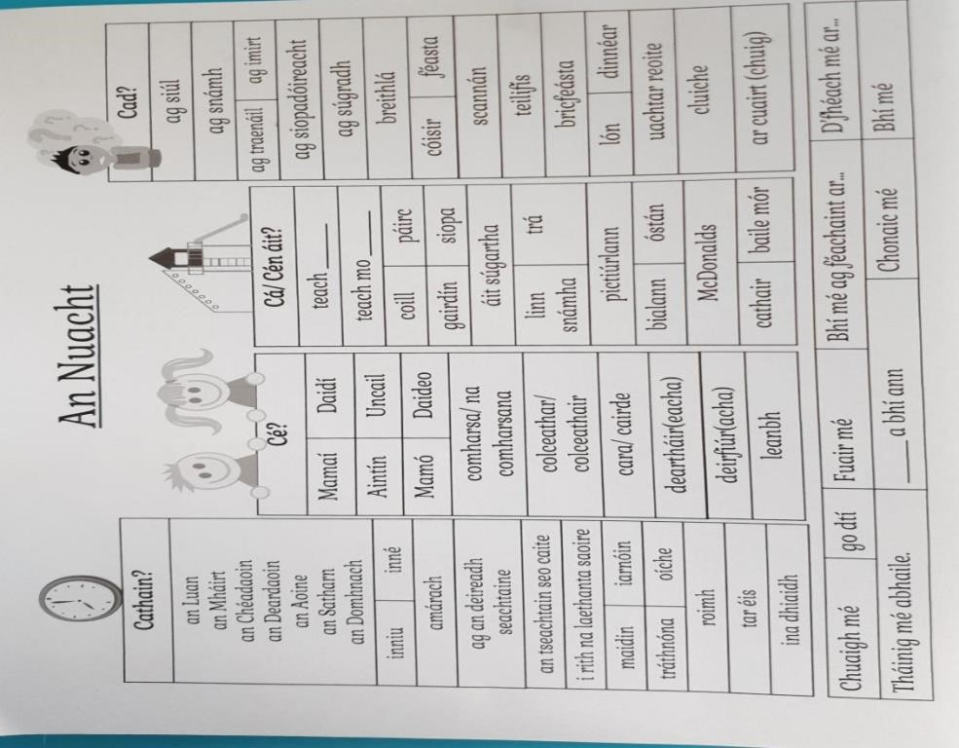

Try practicing your reading in the Leigh sa Bhaile book on cj fallon website. I’ve put in screenshots below to guide you in finding it if you can. Just start at page one. There is an mp3 audio file of the page to help if you are stuck on the words and the pages have good translations of some of the words. Try the first 2 stories this week.
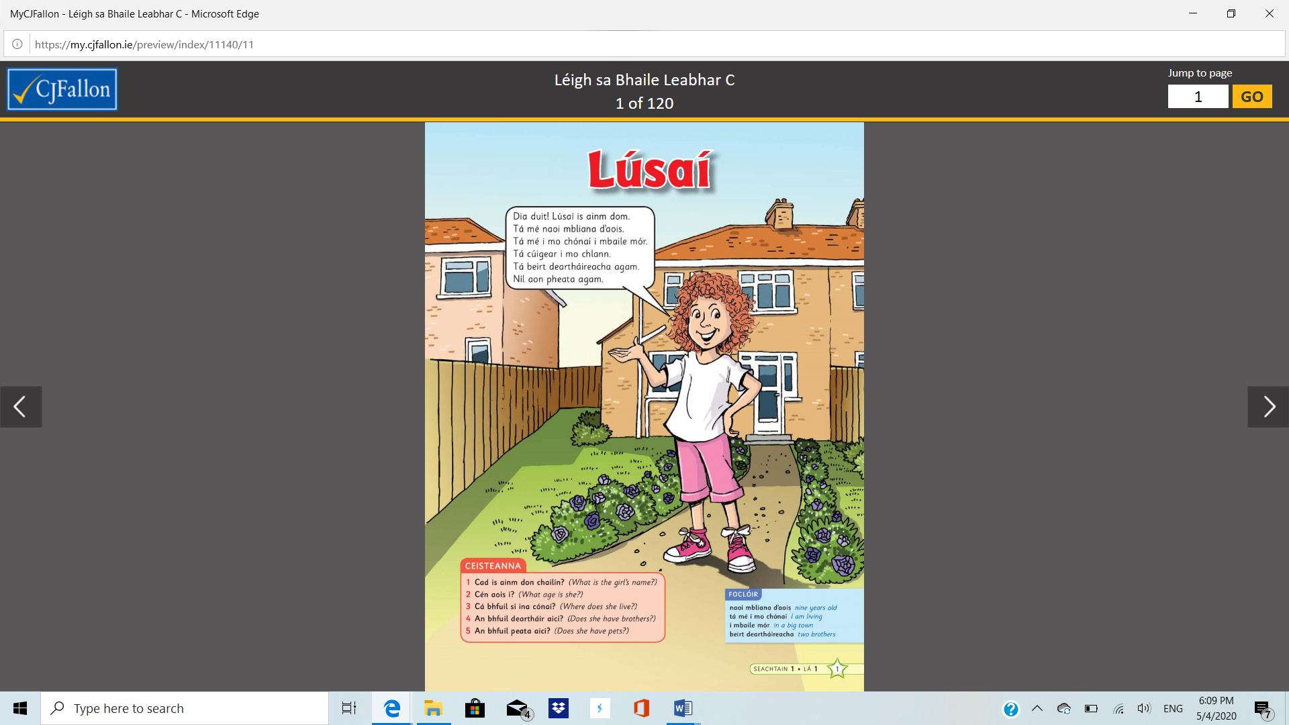
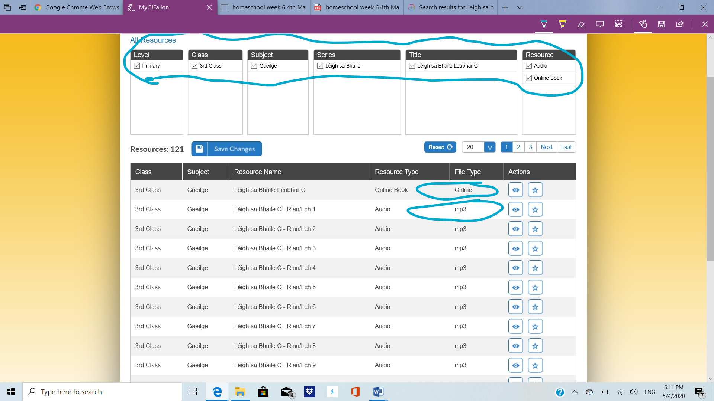

Religion : Mass is broadcast daily/weekly http:/www.mcnmedia.tv/camera/st-eunans-cathedralletterkenny SPHE :
This week we are going to work on Staying Safe at home during the Corona virus:
Look at the sheet below “Staying Safe At Home” and fill out your own chart if you can not print this one, we love reading your ideas.
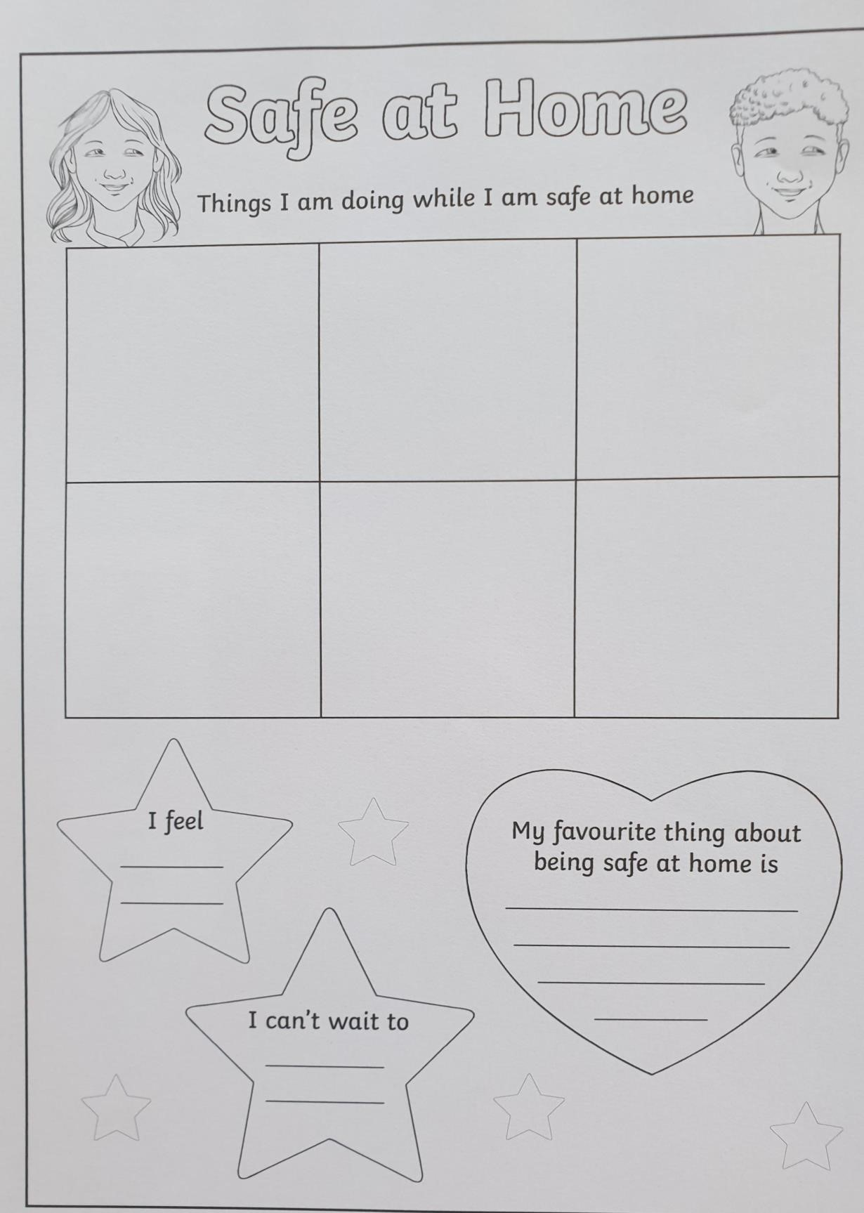

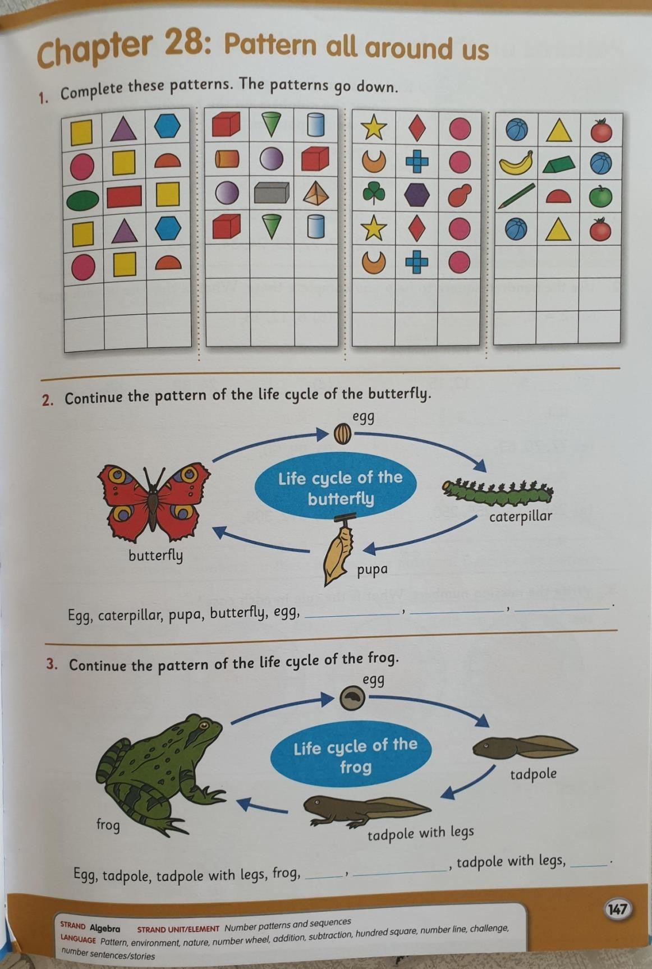

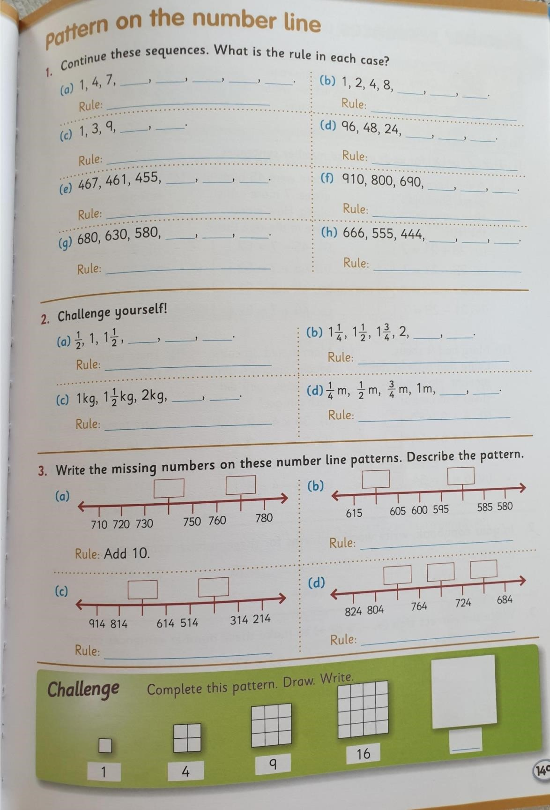

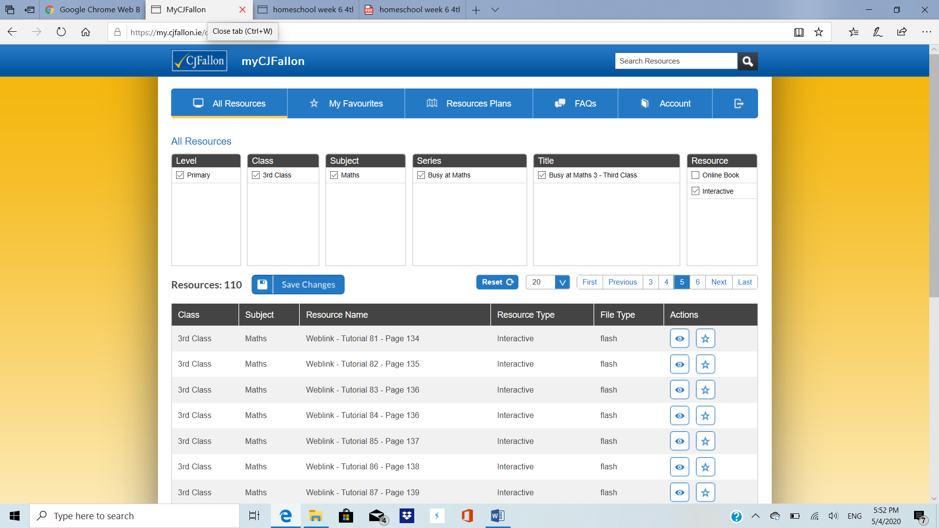

On the cj fallon website, there are also tutorial videos to go with most lessons. We’ve included this screenshot to help find them as we were unable to attach the tutorials as links. There are tutorials for pages 147 and 150 in the Busy at Maths book which you might find helpful.

These links might also help. Lots of you have tried really hard in your Master your Maths and have been doing well with the division questions with remainders.
https://www.khanacademy.org/math/arithmetic/arith-review-multiply-divide/arith-review-remainders/a/understanding-remainders
You could try going to khan academy and go to the multiplication and division section which has video tutorials and questions to practice.
https://www.youtube.com/watch?v=KGMf314LUc0 video on remainders which is quite good but a bit long.

