Mr. Kavanagh’s EAL Pupils

For those students using seesaw follow the steps below to get logged in. Then click on your name to see some of your work from earlier in the year.

You can upload your own work as well if you have time. I would love to see what you have been doing over the past few weeks. Pictures you have drawn, stories you have read or things that you have made!

Hope to hear from you soon

Regards,

Mr.Kavanagh

Get Students Signed In
When you’re ready to use Seesaw with students, they should follow these instructions to sign in.
1. Open the Seesaw Class app on iOS or Android. Or go to app.seesaw.me on any computer in Chrome or Firefox browser.
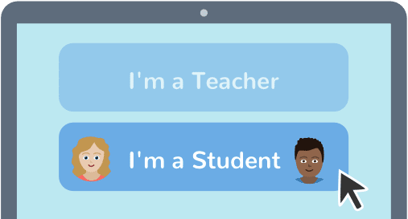
2. Choose I’m a Student.
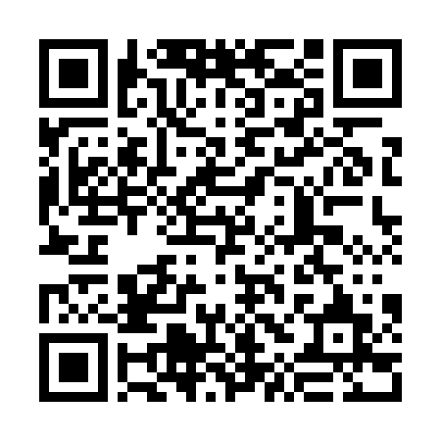
ATSKDI Copy and paste this text code

3. Scan this code using Seesaw’s QR code reader or type in the text code.

